SAFETY COMMITTEE QUARTELY MEETING
JUNE 22, 2017 – 8:00 AM
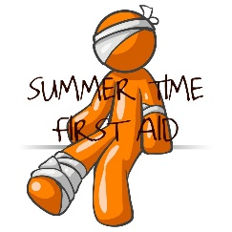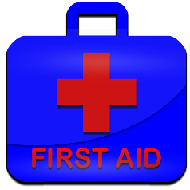

IN ATTENDANCE: KIM COWLES, TIM BLAKE, COREY RUSH, ERIK RASMUSSEN, JIM CYRS II, JEREMY HALL,
CHRISTOPHER GAUTREAU.
INVITED GUEST(S) : MR. BILL BRUSSEAU- LITTLETON EMS- (Retired)
The meeting was called to order at 8:05 am at Franconia Town Hall.
This meeting is The Safety Committee’s 2nd Quarter Meeting for 2017.
Today’s agenda is First Aid. The training and Power Point presentation was presented by Mr. Bill Brusseau ( retired) from the Littleton, N.H. Emergency Management Services Division. Mr Brusseau served for 24 years with The Littleton N.H. Fire Department.
NEXT MEETING: The 3rd quarter meeting will be scheduled by Ms. Kim Cowles. This will be The Safety Committee’s 3rd Quarter meeting . The topic will be: BUSINESS MEETING
_____________________________________________________________________________________
A comprehensive review of the duties and responsibilities was presented, with a lively question and answer forum. Among the vast topics included the following:
1) Assessment & Documentation.
2) Standard Precautions.
3) Medical Emergencies.
4) Environmental Emergencies.
5) Readiness – After the emergency.
The meeting was adjourned at 12:15 pm.
* Attendees provided e-mail addresses at the end of the session to receive First Aid Cards.

Prepared and respectfully submitted by:
Mr. Christopher J. Gautreau

