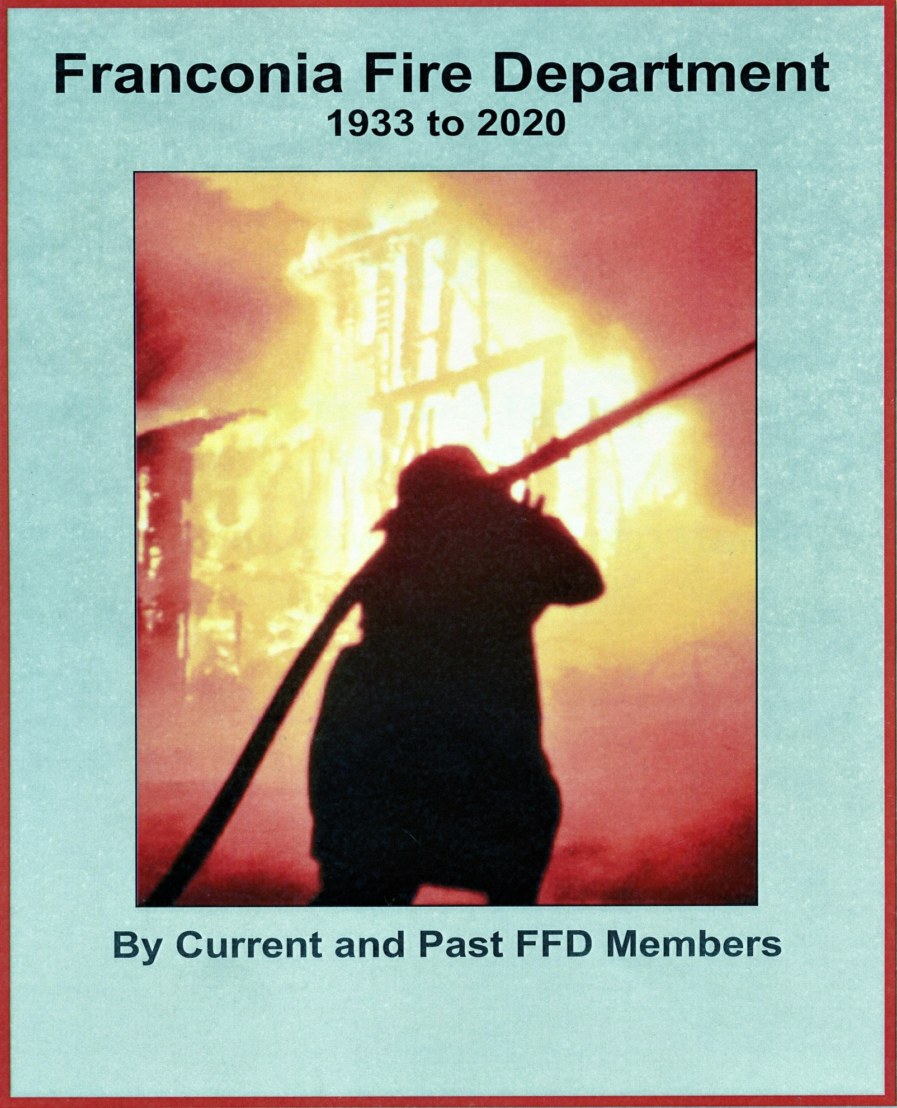
History of the Franconia Fire Department
1933 to 2020

A collaboration of past and present FFD members
June 2020

Contents

5 A Short History of the Franconia Fire Department

By Don Eastman
9 Franconia Fire Department 1933 to 2020
By Stanley Sherburn
19 Equipment of the Franconia Fire Department 1935 to 2020
31 Franconia Fire Chiefs
36 Franconia Fire Dept Roster 1933 to 2020
40 Longest Serving FFD Members

Cover picture by Robert Gilbert Tee & Ski Inn, Franconia, NH Dec. 1969

Introduction
Don Eastman died March 9th, 2010 at the age of 85 years and he was an active member of the Franconia Fire Department up to his passing for over 54 years. I found this history essay he had done with other pictures and articles on a file disk he had left in the file cabinet of the fire department. I am going to attempt to continue his essay with the help of present and past members of the Fire Department and take it to 2020
Stanley Sherburn

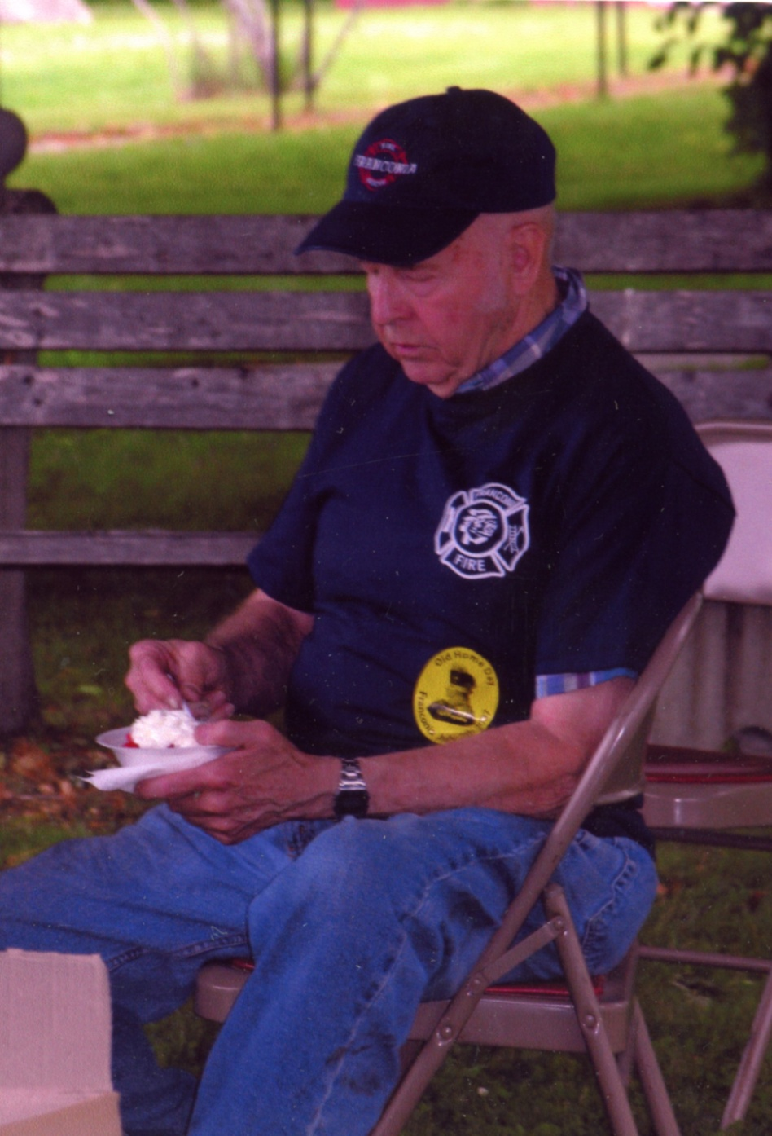
Don Eastman Oct. 14, 1924 - March 9, 2010

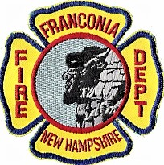

A Short History of the Franconia Fire Department

By Don Eastman

It would appear that the largest single structure fire in the Franconia area occurred on Thursday, August 3, 1923, when the Profile Hotel complex in Franconia Notch burned. Forever lost was a 500 guest hotel which had been in operation for 70 years, 20 private cottages, and a large barn. Also lost was the old Lafayette House which had been constructed in 1835. This was the first hotel to operate in Franconia Notch. It had been moved from its original location a few hundred feet farther south to a new foundation just west of the new hotel as this was being built in 1852. In its new setting, it was used as quarters for the hotel waitresses and chambermaids. The only building that seems to have missed the conflagration was the terminal for the Profile and Franconia Notch Railroad. It was several hundred feet north of the Hotel at the base of Eagle Cliff. For many years it served as the Gift Shop for the NH League of Arts & Crafts. When the Parkway was constructed through the Notch it was torn down to make room for the new road.

Franconia had its share of large fires in the period following the Civil War. Included are the Stone Stack buildings in 1884, the first Dow Academy in 1902, Mount Lafayette House (near Franstead Campground) in 1911, Echo Hill House (on Wallace Hill), the first McKenzie Hotel, Edison House (near the Route 117 Sugar Hill bridge) in 1913, Elmwood, House of Seven Gables, and Franconia House (near Flintlock Motel).

One thing lacking during this time was any sort of organized Fire Department. Once a building started you attempted to save what you could and helplessly watched it burn.

After the 1923 Profile Hotel fire, it appears that some citizens of the town, believing there was a better solution at hand, proposed the purchase of a "fire engine." The Town Report covering the period January 1, 1923, to January 1, 1924 lists the purchase of a Fairbanks Morse Company fire engine for $217.25 and B & M Freight delivery charges for $15.50. I have searched for information on this unit to no avail but assume for the present that it was a one-cylinder engine connected to a water pump.

The engine was stored at Charles. H. Corey's Garage (later A. R. Bowles) for around $50.00 per year and this appears to have included gas & oil and other incidentals as no other charges are apparent to its operation and use. One or more ladders were acquired in 1928 from H. E. Paine for $21.65 for use at fires. The 1932 Town Report indicates that Franconia paid Littleton Village District the sum of $50.00 but I have no idea if this was for fire fighting assistance or equipment. That same report shows an item for $9.01 as "Freight and cartage on the siren." Also included was the sum of $500.00 as the valuation of fire equipment. Even though a regular organized department was not available, the men in town must have stopped whatever they were doing and responded when an emergency developed.

The 1933 Town Report has a Warrant Article “To move the siren and raise and appropriate money for same.” It appears a siren had been acquired on a trial basis and money was being asked for to pay for it. $372.50 was subsequently raised for its purchase and paid to the Sterling Fire Alarm Company. Another item in this report is a payment to "Bert Herbert - fire chief expense" for $6.21. This is the first name I have been able to directly associate with any fire department activity.

The Town Report covering the following year (1/31/34 to 1/31/35) shows "New truck body - American LaFrance" for $5,404.70. There is a line under this that has raised a question I have been unable to get any sort of an answer to and it reads "less $700.00 credit allowed for old truck" with the total payment as $4,704.70. I can only speculate that the $217.25 Fairbanks Morse unit purchased in 1923 was later mounted on a donated truck chassis. I have not been able to find anyone who can remember anything about this unit nor any expense in town funds to pay for it.

The Franconia Fire Department was then organized in 1934 with the acquisition of this new truck. The unit purchased was a 1935 General Motors truck chassis on which the American LaFrance Company mounted a 350 gallon per minute pump, four 10’ of hard suction hose, a 300-gallon water supply tank, booster hose reel with a rubber hose, hose supply bed with 2½" hose and nozzles, ladder, bell, and siren. A fire station was not yet available so it was housed in a stall at Corey's Garage at the lower end of Main Street for a cost of $100.00 per year. Coats and Boots were purchased in 1934 for the sum of $210.10 and helmets in 1935 at a cost of $111.50. Bert L. Herbert was elected the first Fire Chief and he served that post until 1940. Paul Rich was the next Chief with Perry Ball as his assistant. Firemen to receive a salary as listed in the 1935 report were as follows and it can be assumed that most if not all were Charter Members of the new department.

Bert Herbert, Chief Perry Ball, Assistant Chief
Harold Bowles Winton Hunt
William Carbee Elwood Lewis
Harry Carpenter George Miller
Edward Chase Ernest Nelson
Clement Clark John Welch
Harold Clark Paul Welch

Firemen's names were not listed in the Town Reports for the next three years but the 1939 report finds some new names on the pay list.

Perry Ball George Miller
Roy Bowles Carl Nelson, Jr.
Harry Carpenter Paul Rich
Clement Clark Richard Sullivan
Edward Hall Donald Taylor
William Heath John Welch
Jasper Hunt Paul Welch
Elwood Lewis

Perry Ball was elected Chief in 1941 and held the post until he passed away in 1954. Edgar Dexter was appointed to fill out his term and was reelected the following year. In 1956 Merton Shores became the fifth department chief and held the post until ill health forced him to retire in 1965. His Assistant Chief for many years was Richard Sullivan, and later Charles Henry Herbert. Herbert, better known as Sonny, assumed the post in 1966 and continued till January 1968 when he died of a heart attack at the age of 35. Mert Shores was reappointed until a new member could be trained and able to assume the Chief's duties. Jon Whitcomb was elected in 1970 and left in 1973 to become a permanent member of the Hanover Fire Department. Another former Franconia fireman, Mike Doolan, is also a member of that department. Other Chiefs of our department have been Roger Odell, George Whitcomb, Ronald Hunt, and as this is being written in 1990, William Mead. The department has been very lucky to have had such dedicated men serve in this capacity. Each in his own way has brought leadership and experience to the men assembled under him, no mean task with a volunteer group of this sort.

With only one truck available and that necessarily at the source of water, those early firemen had a major problem in setting up fire streams to a working fire. Lacking hydrants of any type, they put a suction hose in the Gale river if it could be reached and did the best they could. Littleton was the main source of backup help and one must be aware of the fact that a trip into Franconia on the roads before the Interstate was a much slower procedure.

After the acquisition of the American LaFrance it soon became apparent that a second piece of equipment would be a valuable asset. The advent of WW II made any new purchases impossible for several years but once automobile and truck production resumed in 1946 a new truck was ordered.

This was a standard 1947 Chevrolet chassis having a 250 gpm pump and a 500-gallon booster tank. The bid price on this unit was $4700.00. The two trucks were now housed in the basement of the Town Hall, which had been built in 1937.

The old LaFrance served the department well for 25 years but definitely was not up to required standards in 1961 and was replaced by an International chassis with bodywork being accomplished by the Moody Company in Nashua, NH. This unit cost was $13,000.00 and came with a 750 gpm pump, a 750-gallon booster tank, the first 35 foot ladders the firemen had to use, and an adequate hose bay area for a good supply of both 1½ and 2½ inch hose. The first two-way radio equipment available to the department was also installed at that time consisting of short-range CB transceivers.

About this time the Water Department installed a few small fire hydrants on Lafayette Drive, Harvard Street, and Academy Street. They could only serve as tank refills because the underground water lines in place were too small to provide a substantial supply. It was however certainly reassuring to the men on the scene that something extra was immediately available while larger lines were being connected from the river.

The Fire Station was constructed in 1969 on land donated by the Raynor family, just south of the Route 142 turn to the old Forest Hills Hotel property, and continuing up to Mt. Aggissi to Bethlehem. The contractor that was awarded the construction bid was Robert Lawrence and his foreman on the job was Merton Shores. As Fire Chief, Mert had made a special commitment to getting his men and their equipment into more satisfactory surroundings. The stalls in the Town Building had minimal top and side clearance, having been planned for equipment sizes that were prevalent when it was constructed in 1937. Even after alterations were made to widen the doors as much as possible, the 1970 International could barely fit through them. The uphill pull from the station doors and the possibility of a crowded parking area left a lot to be desired as equipment was pressed into service. The siren had now found a permanent home, being mounted in the cupola on the Town Building roof.

The lot for the new station was cleared of trees by the members of the department and the brush burned. As the ground level was almost ten feet below street grade, fill was trucked in from the McGowan Hill gravel pit by the Town Road Agent. Footings were set and construction began in earnest. The contract cost was $50,000 including furnishings. This beautiful new building has three bays that are 60 feet deep, an upstairs meeting room with a separate kitchen and bathroom, and facilities for the Franconia Police Department.

With the purchase of a Mack diesel Attack Pumper in 1973 to replace the 47 Chevrolet, the future outward appearance of the department's equipment took a major change. The standard color for fire equipment since time immoral had always been “fire engine red.” Yellow was being tried in other areas for its better visibility, and the members voted to adopt it as their official color scheme. This truck was ordered from Pierre Thibault in Canada to specifications decided upon by a truck committee composed of several members of the department. This unit was equipped with a 1000 gallon per minute pump and carried 1000 gallons of water in the booster tank. Large compartments were provided for Scott Air Packs, a 7 hp portable pump, a 120 volt 3000 watt Kohler generating plant, floodlights, necessary hose fittings, dry chemical, and CO² extinguishers, and protective gear for the driver and his helper. It also had a side-mounted 35-foot aluminum ladder and a 10-foot folding attic ladder. Mounted on top of the compartment just behind the cab was a deluge gun capable of an 800 gallon per minute fire stream.

The next department acquisition was an L900 Ford in July of 1979 to replace the 61 International. It was assembled by Four Guys, Inc. of Meyersdale, Pennsylvania, and came with a 1000 gallon per minute pump mounted in front of the engine on an extended bumper mount. It was to be used in a dual-purpose role as a source pumper and tank truck. The 1,500-gallon tank was constructed of stainless steel and has a quick dump valve in the rear that permits the gravity discharge of this supply in about 3 minutes. This is used to fill a portable holding tank when a tanker relay system is adopted as the fire fighting mode. The truck has four 10 foot sections of 5" hard suction hose in trays on one side of the tank and a 35’ aluminum extension ladder on the opposite side. It carries a floating dock strainer, has compartment room for a portable pump along with air packs and special fittings. The hose bay above the tank has space for several short fire fighting lines and approximately 1500 feet of 4" supply hose.

To be continued - - - Emergency trucks (Dodge, International, Chevrolet), Jolly Green Giant tanker, Dodge and Ford equipment vans, International hose truck, 4" hose from Cannon, Twin State call system, building modification, Hayseed events, Musters, major fires, LaFrance restoration for 1972 200th Franconia anniversary.
Don Eastman

Franconia Fire Department 1933 to 2020
By Stanley Sherburn
In 1933 when you reported a fire you would call the local phone operator, Franconia had a telephone switchboard office on Main Street, operators would take your call and connect you to whoever you were trying to reach. When you needed to report a fire you would call the operator and he or she would take the information and then activate the fire siren. Firefighters would have to call the operator to see where the fire was. In the early 1950s, the phone company made changes eliminating the local telephone operators. In doing so the town lost its ability to answer fire calls with a local phone operator. The 1953 Franconia Town Report under detail expenses for the fire department there was a payment to the New England Telephone Co. of $183.83 for fire phones. That is when the "Red Phones" came into existence for the town. The red phone system was a party line of 4 to 5 phones that were placed in several businesses and homes of the fire chief and other fire department personnel. When you needed the fire department you would dial 5644. All of the red phones would ring and you would report your emergency to whoever answered and then they would activate the siren and stay on the line and wait for firefighters to pick up an extension and get the information for the emergency. The fire department had to install and maintain the wires for the siren from the red phones to the fire siren on the town hall; every red phone had a black switch behind it to” blow the siren”.
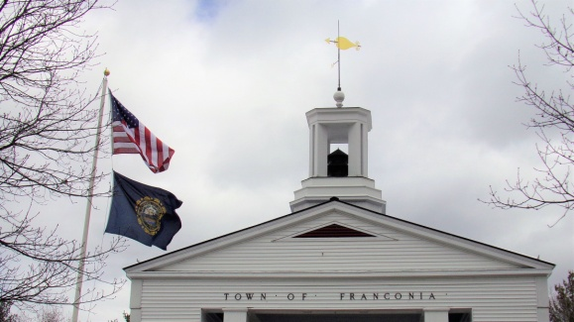 Siren on the Town Hall
About 1970 the Franconia Fire Department got its own FM radio system with a dedicated fire radiofrequency. The Sugar Hill Fire Department owned the original radio frequency license and gave the Franconia Fire Department permission to share it. This radio frequency eventually became the primary fire frequency of the Twin State Mutual Aid System and is still being used in 2020 for the Twin State Dispatch Center. Before the FM radio, the fire department used Citizen Band (CB) to communicate amongst themselves and perhaps with other departments that had CB radios. With the introduction of the FM radio system, the fire department also got home receivers or as the firefighters call them “plectrons" that would be “toned" from the fire station to announce the emergency. These receivers were a stationary unit that the firefighters usually left in the bedroom or living room of their homes. A few years later the fire department started using portable pagers that could be carried with the firefighters. The Fire Chiefs Report in the 1980 Town Report mentions that the fire department budget included money for 8 more pocket pages.
The Twin State Mutual Aid Fire Association in 1976 started talking with Grafton County Sheriff's Department in North Haverhill N.H. about them doing a fire dispatching service for the 15 mutual aid towns. November 12th, 1978 Twin State Fire Dispatch began a 6-month trial with the Grafton County Sheriff's Department after which a review was made and then permanent arrangements made. On Nov.3, 1980 The Town of Franconia started using the Grafton County dispatch service for all police and fire emergency calls. You would dial 8123 to report your emergency and the Dispatch Center would then dispatch the fire or police department, eliminating the red phone system and soon the siren.

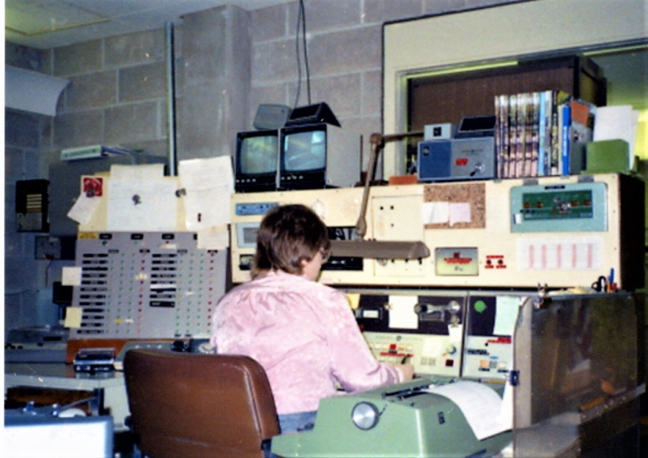
Grafton County Police, Fire, EMS Dispatch Center 1981
The Fire Chief Report in the 1991 Town Report noted “the emergency phone system 9-1-1 is now operational”. Today when you need emergency help you will dial 9-1-1 and within seconds a trained emergency operator will take your call and dispatch the fire department or whatever department you need. Franconia is still a volunteer department, the same as in the 1940s and 50s and the firefighters still have to come from their homes or work to help with your emergency. Unlike our earlier fire department, today's fire department is responding within minutes of your emergency call, not the 10 to15 minutes it would take you in 1950 to call the operator, have them sound the alarm, have enough firefighters hear the alarm and respond to the fire station, figure out where the fire is and start responding to your emergency.
In the 1960s, Franconia Fire Department, and firefighters were referred to as "Cellar Savers” as were most other departments. The rural small-town fire department such as Franconia with a limited usable supply of water and equipment found it difficult to make a stop on a working structure fire. If the attack was made with two (1 1/2”) hand lines there were about 8 minutes of water available from their trucks and if there was other nearby water available from a pond or stream that could be quickly accessed and pumped to the scene without a long interruption of water to the fire there was a good chance the structure could be saved. Too often the water supply could not be established soon enough because of distance or cold weather to be helpful, and then the fire would go quickly from a 200 gallon per minute fire to a 600 gallon per minute fire and become hopeless. The house burned to the ground and all that would be saved was a cellar. The 2020 Franconia Fire Department still only has about 16 minutes of water available from its trucks to attack that same 1968 structure fire, but today's fire department is very different than the 1968 fire department in many ways. The 1968 department had 2 Self Contained Breathing Apparatus ( SCBA ) and 5 or 6 spare air tanks for a limited interior attack, today there are 10 SCBA and about 10 spare tanks, enough to conduct a search and allow two teams of firefighters with hand lines into the structure and more efficiently put the limited amount of water onto the fire. But also today’s department has many other advantages, an aerial ladder for better access, a large-diameter hose that can be quickly set up and pumped when nearby waters are available, large-capacity truck tankers to move water, mutual aid from other departments, and a host of other equipment to help put out today's fires. Perhaps the most important changes to today's fire service may not be the much-improved equipment and techniques used to put out the fire. It would be the Building Codes, Life Safety Codes, 9-1-1 emergency services/ dispatch centers, and the number one improvement for the fire service and life safety would be the smoke detector. The smoke detector has saved an untold number of lives and gives early warning of a fire before it gets too big and uncontrollable. These changes are most evident in today's dramatic reduction in loss of life from smoke and fire and the number of fires the fire department responds to.

Prior to 1938, before Franconia built a new town hall, the fire equipment was stored in rented space in local garages. In 1938 or1939 the new town hall was completed and a two-stall garage was provided for the fire department under the town hall. This space worked well until 1961 when the International fire truck was purchased and it was too large to go through the small garage doors. With a larger door and some modifications made the new engine was able to fit into the fire station.
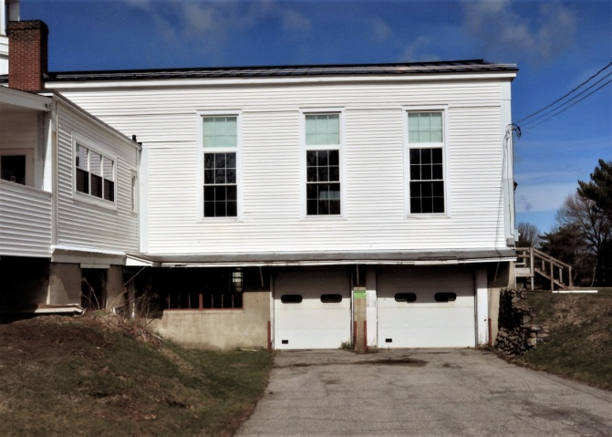 FFD station at the Town Hall 1939 to 1969
With the fire department growing and the town's desire for better fire protection, the fire station under the town hall was no longer adequate. The 1967 town meeting had an article to purchase land on Main Street for a new fire station, this article was not passed. Soon after, Mr. and Mrs. Newton Raynor owners of Raynor's Motel donated land for a new fire station to be built on, and the March 12th, 1968 Town Meeting authorized $50,000 for its construction.
The firemen cleared the lot and the construction was done by Robert Lawrence of Franconia. Once again this fire station served the community well until about 2012 when, with the high cost of energy to maintain the building and the needs of both the police and fire departments for more space, it was once again decided to build a new building. The March 11th, 2014 town meeting authorized $1,900,000 for the demolition of the old station and the construction of a new Public Safety Building on the same location. The departments moved into the new building in January 2015.
In the early seventies, there were several structure fires at the Mittersill Resort in Franconia and the Homeowners Association pushed for better fire protection for the resort. The Town Meeting of March 5th, 1974 authorized $28,000 for the construction of a Fire /Highway station at the Mittersill Resort on land leased from the state of New Hampshire. The fire department maintained fire equipment in this station for several years until it was decided the substation was not working out as planned and closed it as an active fire station.

The state of New Hampshire with financial help from the federal government in 1972 was trying to establish in the rural communities Fast Quads (first aid stabilization teams) to get them better emergency medical help and to assist the local ambulance companies. These fast quads would be first to arrive on the scene and help stabilize the patient and have them ready to transport when the ambulance arrived. In the 1970s and prior to, most small rural towns did not have any emergency medical services of their own and so Franconia, Sugar Hill, and Easton used Ross Funeral Home and Pillsbury Funeral Home from Littleton to provided ambulance service for medical emergencies. In 1969 Pillsbury Funeral stop providing Ambulance Service and Ross Ambulance continued on with 24-hour coverage.
William Mead, Joel Peabody, Michael Doolan, and Cray Ball in 1972 were the first firefighters from Franconia to get their EMT ( emergency medical technician) certificates and established the Franconia Life Squad that would serve Franconia, Easton, and Sugar Hill. Members had emergency jump kits that they carried and shared the fire department equipment van for other emergencies medical equipment. In 1981 the Life Squad got its own rescue truck, a four-wheel-drive truck with an enclosed utility body.
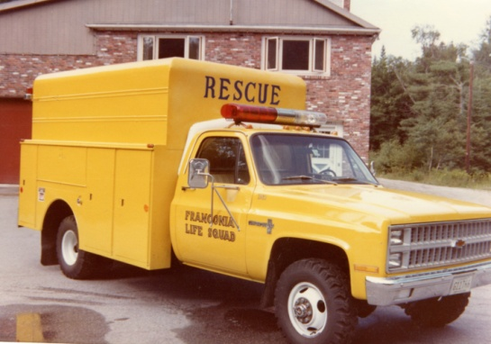 1981 Emergency Medical/Rescue Truck
The Life Squad continues to grow and in 1996 got its first Road Rescue Ambulance and was soon transporting patients. Today the Life Squad continues to be a vital part of the community and is still giving emergency medical / ambulance service to the towns of Franconia, Easton, and Sugar Hill with Sugar Hill contracting with Littleton Fire for their ambulance service.

From 1933 to 2020 Franconia Fire Department has had 14 Fire Chiefs with Paul Rich and William Mead serving the longest at 14 years each. Merton Shores served 12 years, Rick Gaudette (current chief) 10 years, and Roger Odell 9 years in 3 separate terms. Also since 1934, there have been approximately 175 firefighters who have served the town with Phillip Payette serving 56 years, Don Eastman 54 years, and George Whitcomb 51 years. There have been several women firefighters on the Franconia Fire Department with Lisa Champagne being the first joining in 1976. Lisa is the daughter of FFD firefighter Damus Champagne.

Other Activities of the Franconia Fire Department, Life Squad
A volunteer fire department is not just an organization that responds to fires and other emergencies. It is an integral part of the community that it serves and participates in various community projects and activities. In late 1979, a local restaurant owner Jack McGurin and friend Gary Young organized the first Hayseed Musical Festival in 1980 to raise money to support the Franconia Fire Department and Life Squad. Their goal was to help purchase a new 1981 Chevrolet chassis and have an enclosed utility body installed to be used by the Life Squad. The music genre was bluegrass and a bit of country, and area musicians were recruited to volunteer their services. The fire department and auxiliary members provided manpower to set up the Dow Strip for the Hayseed, providing manpower for the refreshment tent, and clean up afterward. Hayseed became an annual event on the third weekend of July and lasted for 16 years. In time the Sugar Hill Fire Department also participated and received financial assistance from the proceeds as well.
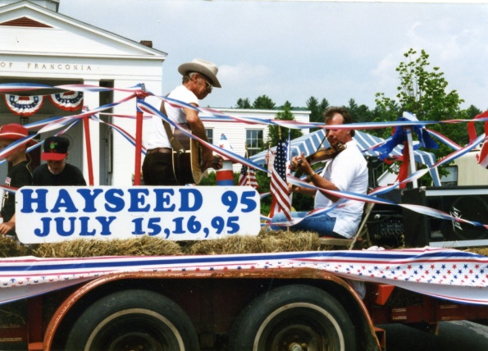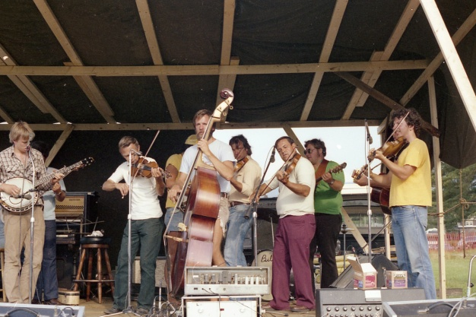
Gary Young on the 1995 Hayseed Float One of the bands

The fire department participated in numerous parades over the years, as did the Woman Auxiliary. Fire department members have cooked barbecues and "bean hole beans" at many functions, and for the past, 20 years or more have provided vittles and refreshments at the annual Franconia Old Home Day in July. Monies received are used for many purposes including the purchase of fire department equipment, provide fire department members with class A uniforms for attending funerals, parades, and other formal functions as well as t-shirts, hats, and other miscellaneous apparel. In recent years another project has been providing scholarships to a graduating FFD member child. Money raised is also used for some social functions, such as the annual Christmas gathering of members, and the annual Wives Appreciation Night Dinner. Social functions contribute to improving friendship, cohesiveness, and morale of members, which contributes to improving team efforts at a fire or other emergency.

1980 Franconia Fire Department Muster

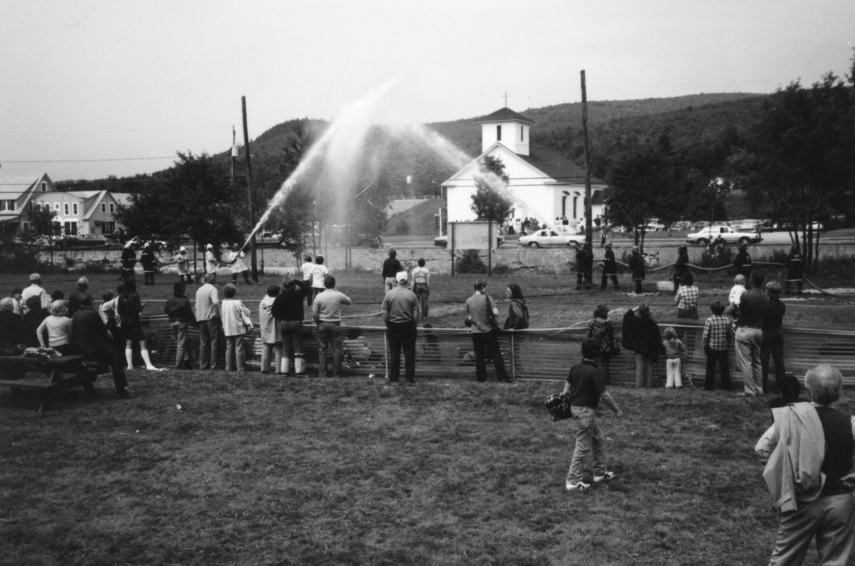

Around the mid-1980s, fire musters became popular in the Northern half of the state. Towns would sponsor a muster, and area fire departments would send teams to compete. Contests varied from muster to muster. A contest might involve two teams forming bucket brigades, and seeing which team could fill a 50-gallon drum first with water from a source, generally a portable tank. Or two teams competing to see who could raise a ladder the fastest to a fixed platform have a member climb to the top and ring a bell. The Franconia Fire Department sponsored a muster in August of 1981 on the Dow Strip. One popular contest was a wire stretch between two installed poles; a target on a ring is attached to the wire. Two teams, with hoses, are attempting to drive the target to the other team's pole. The team that accomplishes that wins. The contests had little to do with firefighting tactics, but since firefighting is a team effort, these musters contributed to, not only the camaraderie and friendship within the department but also with competing teams from other departments. These same firefighter team members may in the future, and frequently did respond to the same mutual aid fire, and work together to bring the fire under control.
These events also contribute to retaining membership. Retention is a major nationwide problem in volunteer fire departments, and Franconia is no exception.

The Franconia Fire Department has had seen many changes since 1933 when there was virtually no fire protection, with today’s fire service completely different with its modern fire equipment, communications, and codes. There is one thing that has been steady and true for the last 86 years and that is the dedication of all the men and women who have served on this volunteer department along with the support of the community that makes the Franconia Fire Department.

Franconia Fire Department Women’s Auxiliary
The Woman's Auxiliary also had a long history of service to the department and town. The Franconia Fire Department Woman's Auxiliary was started and formed in 1968 to support and assist the fire department. They would bring food and beverages to the firefighters working on the larger fires and buy miscellaneous equipment and supplies. One of the larger pieces they bought was the used 1965 Ford Econoline van that was used for FFD equipment and the newly organized Life Squad. They also set up and supplied the kitchen at the new fire station in 1969 and sponsored a Girl Scout Troop. Their main fundraiser was the “Mini Festival" at the town hall that consisted of pony rides, games, treasure &trash table, chicken barbecue and dance. They also help the Lafayette Regional School hockey team in 1974. When Franconia celebrated its bicentennial in 1972 the Franconia Police Department turned to the FFD Woman's Auxiliary and recruited most of the members to be part of the police department to help with directing traffic, providing assistance and information to those attending the activities, and providing security at some venues. Following the bicentennial, the members were sworn in as part-time police officers, equipped with police uniforms, and performed many functions. They directed traffic at parades, assisted the police on Halloween, and performed traffic control duties for road contractors on 1-93, and other state roads in the area. The Women's Auxiliary ceased operations in the late 70s.

Auxiliary Members
Amy Bahr Ann McLachlin
Sue Briggs Joan Mead
Lois Champagne Kathy Mead
Lucy Finn Jenifer Odell
Mary Ellen Gilbert Annie Payette
Ruby Heath Tina Peabody
Ellie Herbert Lovett Mrs. Sykes
Elsie Hunt Kay Whitcomb
Priscilla Hunt Linda Whitcomb
Barbara Leona

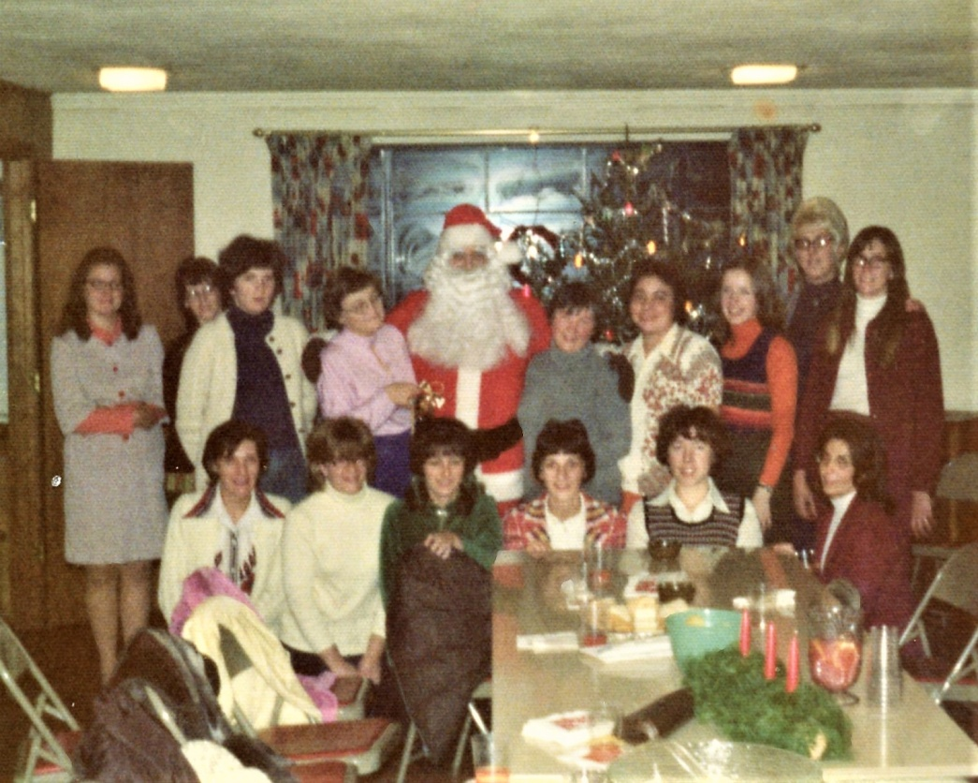 Christmas 1973
Back Row: L to R- Unknown, Tina Peabody, Linda Whitcomb, Ruby Heath, Santa, AKA Ernest Doolan, Ellie Herbert Lovett, Annie Payette, Unknown, Joan Mead, Sue Briggs
Front L to R- Evelyn Hening, Priscilla Hunt, Barbara Leonard, Mary Ellen Gilbert, Lucy Finn, Lois Champagne

Mini-Festival 1971

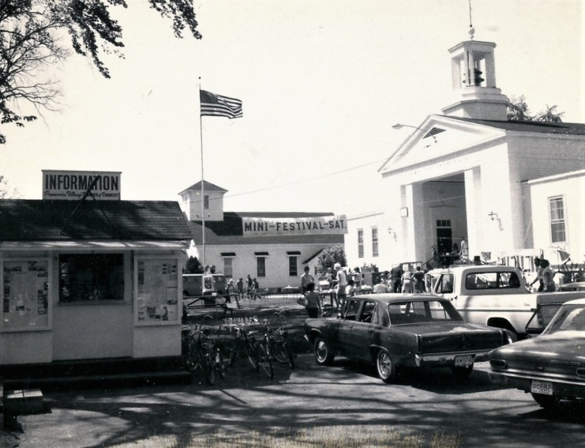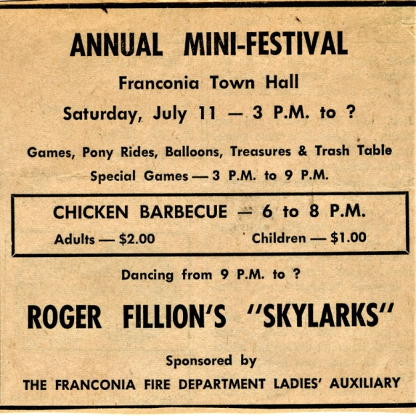

Women’s Auxiliary participating in the 1974 Bethlehem Bi-Centennial

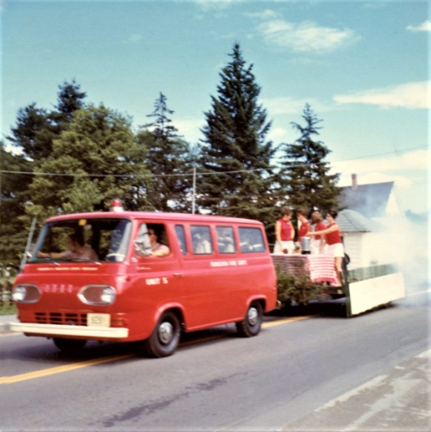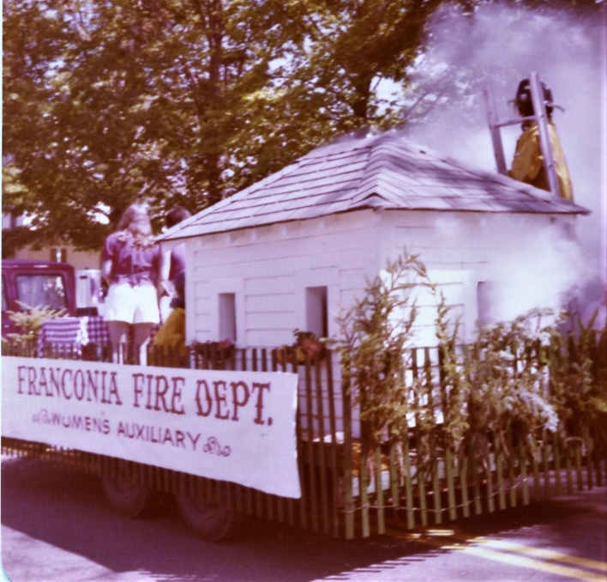

Chicken Barbecue at the 1971 Mini-Festival
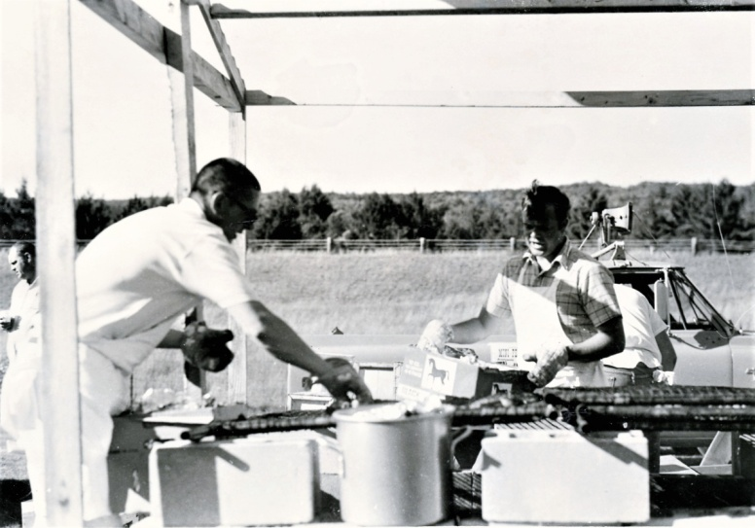
Tamarack Tennis Camp fire July 15th, 1971, Women's Auxiliary providing lunches and drinks to the firefighters
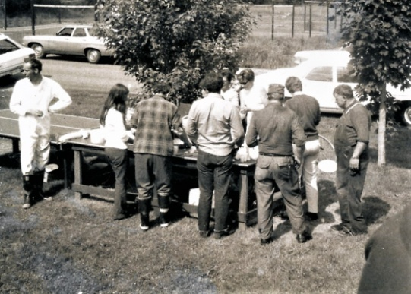

1972 Franconia Bicentennial
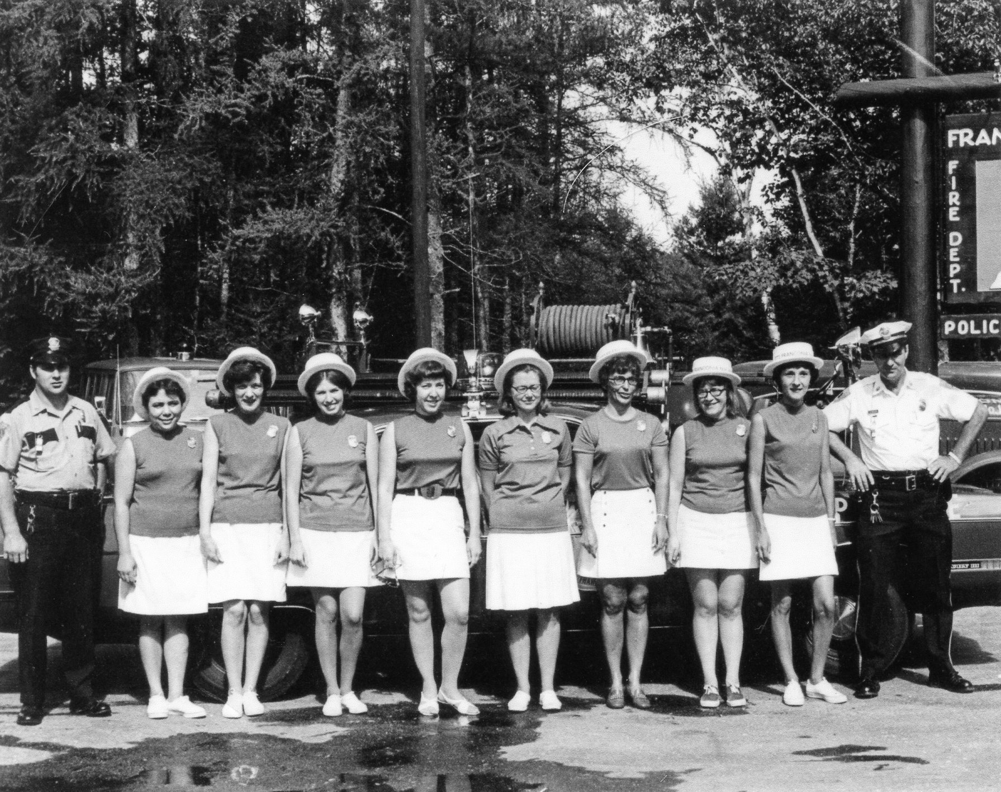
The Woman’s auxiliary helping the police department
L to R Officer Charles Casey, Annie Payette, Evelyn Hening, Jenifer Odell, Lucy Finn, unknown, Louis Champagne, Priscilla Hunt, Mary Ellen Gilbert, and Chief Ernest Doolan

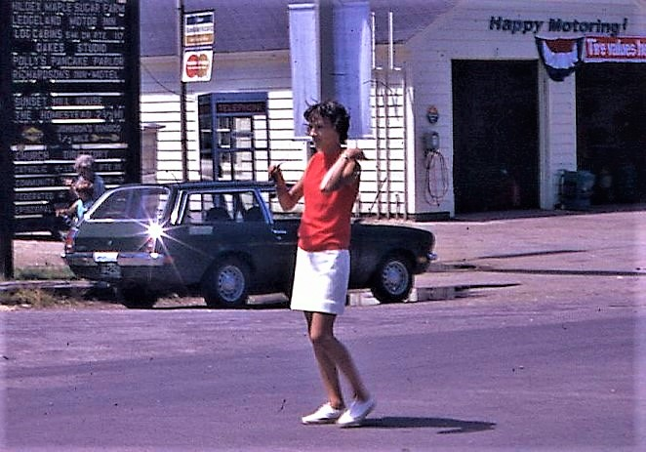
Mary Ellen Gilbert directing traffic for the1972 bicentennial
Equipment of the Franconia Fire Department 1935 to 2020
1935 American LaFrance mounted on a General Motors Truck chassis. 350 GPM pump and 300-gallon water tank. The 1935 Town Report had noted that the town borrowed 4 Notes of $1000 each to purchase a fire pumper.
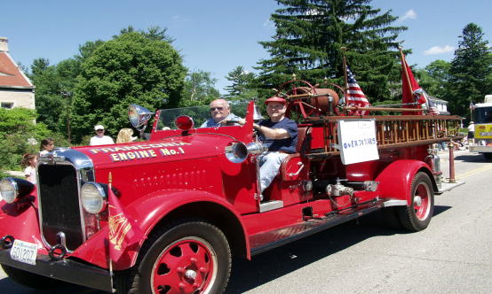

Franconia Fire Station under the Town Hall 1938 to 1969
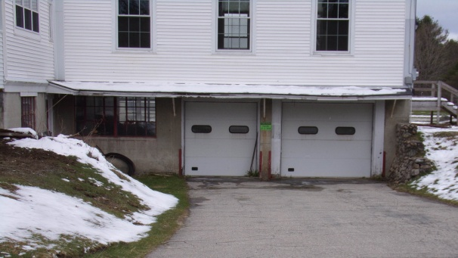

1947 Chevrolet chassis 250 GPM pump and 500 gallon water tank 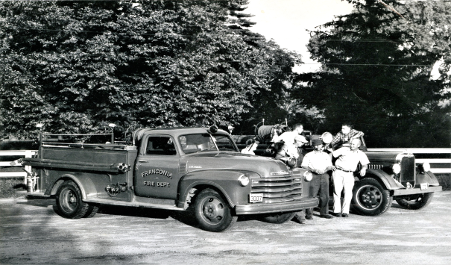
In the 1961 Town report under fire department equipment inventory was listed a 1954 Dodge emergency van, which appears to have come on this inventory list in 1958. No picture

1961 International chassis and body by Moody Co. of Nashua N.H., 750 GPM pump, 750-gallon water tank (replaces the 1935 LaFrance)
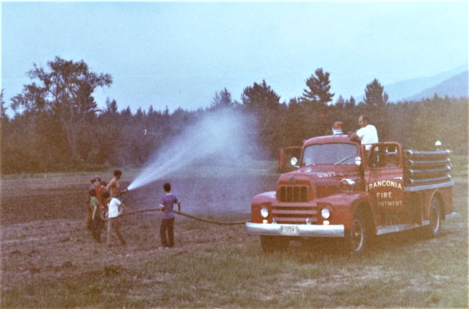

New Fire & Police Building 1969, moving from under the Town Hall. The March 12, 1968, Town Meeting authorize $50,000 for construction
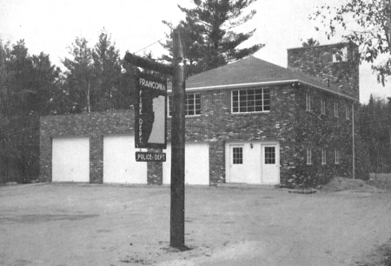

In 1970 the fire department acquired a military surplus chassis (REO) from the state and the members installed a water pump on it for the first water tanker. It was dubbed the "Jolly Green Giant”

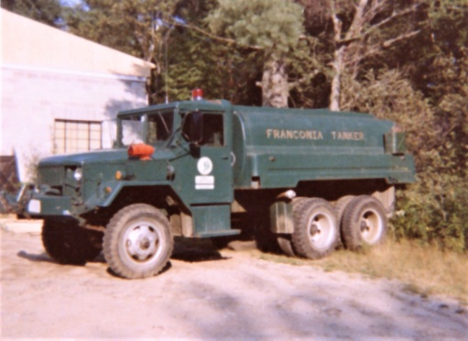

Equipment van acquired by the Ladies Auxiliary about 1970. Used 1965 Ford Econoline van, set- up by FFD members.
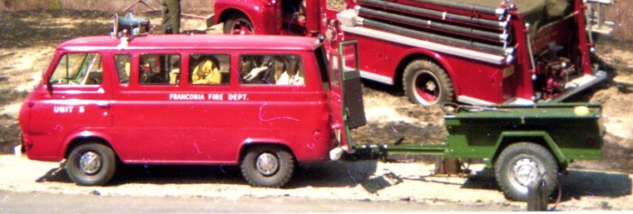

1973 Mack chassis with a Thibault body, 1000 GPM pump 1000 gallon water tank. Delivered June 1974 (Replaces the 1947 Chevrolet)
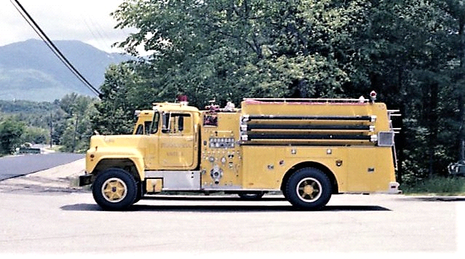

1974 Mittersill Fire/Highway Building. The March 5, 1974, Town Meeting authorizes $28,000 for construction.
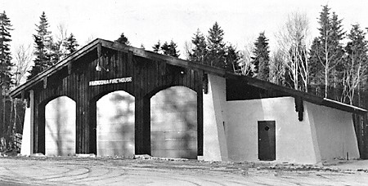

International Step Van acquired in 1976 and converted to an equipment truck by the FFD members. (Replaces the 1965 Ford Van)
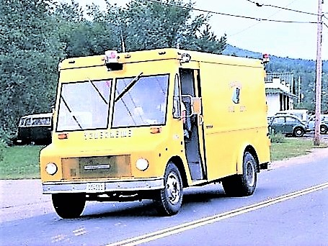

1979 Ford L900 chassis with a Four Guys body. 1000 GPM front mounted pump and 1500 gallon stainless steel water tank and quick dump. (Replaces 1961 International)
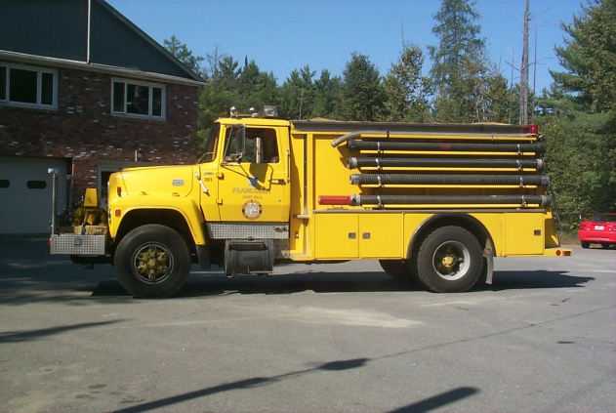

About 1981 Franconia Fire Department purchase (military surplus chassis) a used 1967 Dodge dual cab truck and had an enclosed utility body install for equipment/ rescue truck. (.Replaces International Step Van)
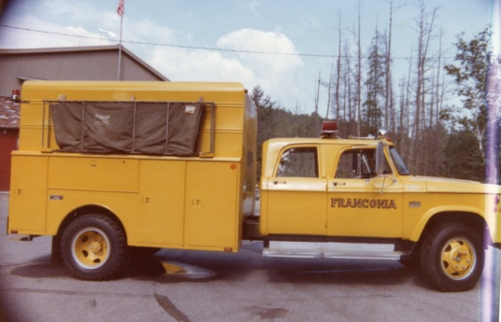

Also in 1981 the Franconia Fire Department purchased a new 1981 Chevrolet chassis and had an enclosed utility body installed to be used by the Life Squad.
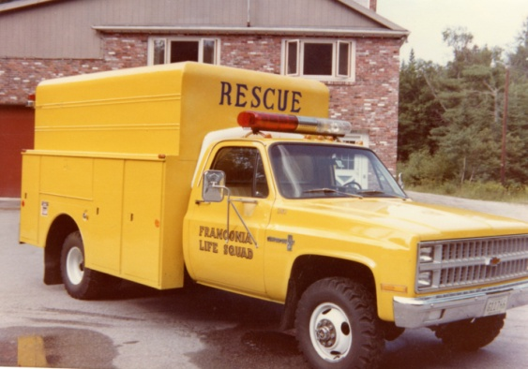

Sometime in the mid-1980s, the state of New Hampshire (Cannon Mountain) gave the Franconia Fire Department 5000 feet of 4“diameter hose and FFD got this International chassis and body from military surplus to carry the 4” hose. The fire department used this truck until about 2003 when the department got a new engine/ tanker (engine 1) where the hose was divided between Engine 1 and Engine 2. The International continued being used for Forestry for a few more years.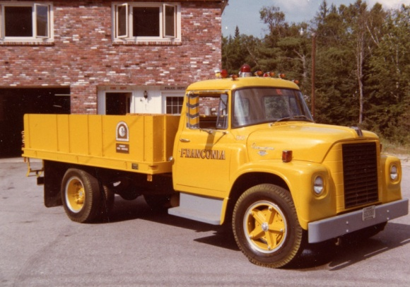

1988 Ford 450, Equipment truck. Reuses the body from the 1967 Dodge Equipment truck 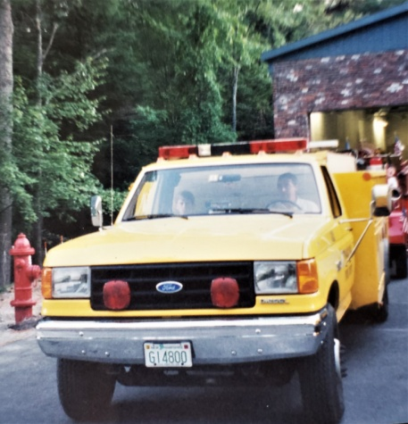

1992 Sutphen custom chassis and body. 1250 GPM pump and 1000 gallon water tank. The March 10, 1992, Town Meeting appropriated $194,500 for an engine. (Replaces the 1971 Mack)
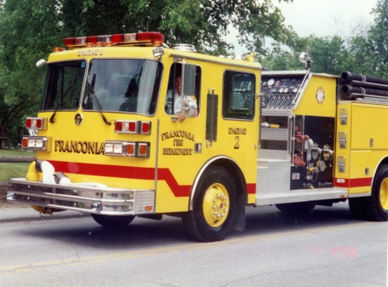

1996 Road Rescue Ambulance Franconia Life Squad first ambulance
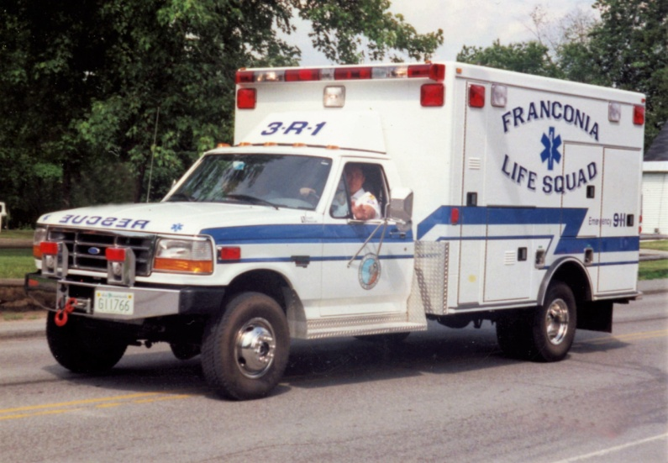

Engine 1, 2003 Kenworth chassis, composite body and water tank by Valley Fire Equipment, Bradford, NH. 2500 gallon water tank and a 1250 GPM pump. (Replaces 1979 Ford)

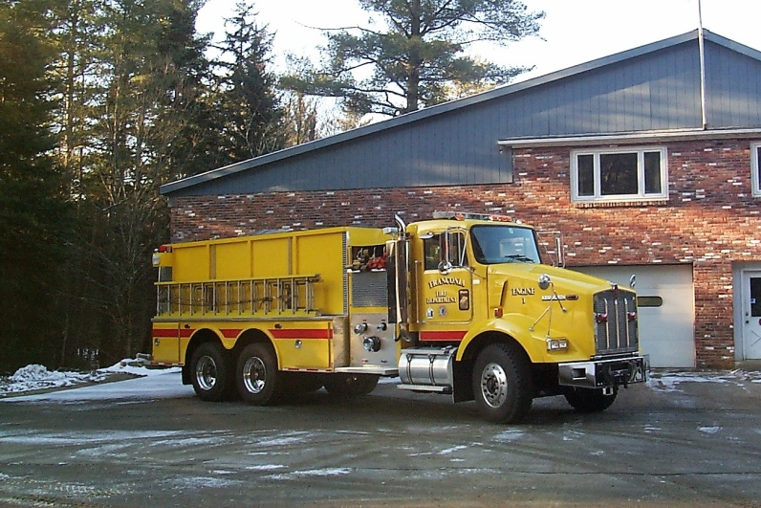

2007 Franconia Life Squad Ambulance (replaces 1996 Ambulance)
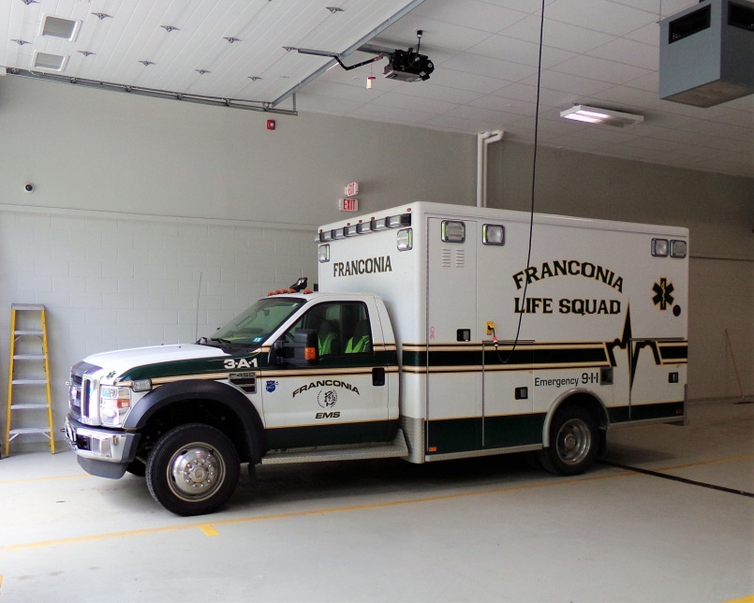
Engine 2, 2008 Kenworth chassis reusing the pump, stainless steel body, and composite water tank from the 1993 Sutphen. Valley Fire Equipment of Bradford New Hampshire did the work. (Replaces the Sutphen)
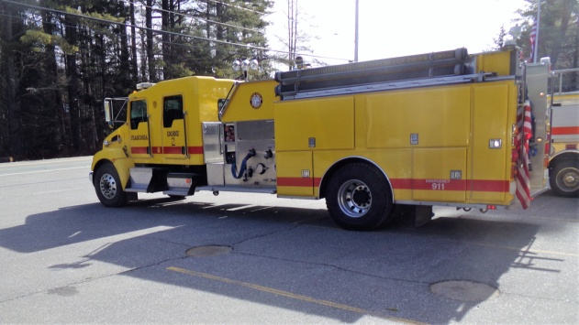

Rescue 2, 2009 Ford 550 with a custom rescue body

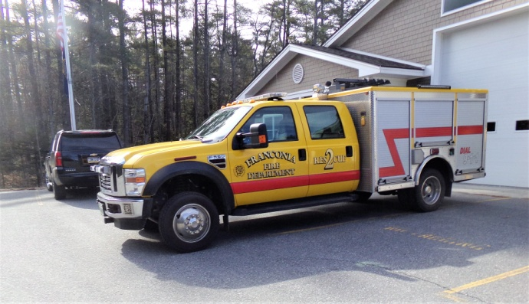

2014 the old fire/ police station was demolished and a new Public Safety Building was built on the same location for the fire and police departments. The March 11, 2014, Town Meeting authorize a gross budget of $1,900,000 for construction
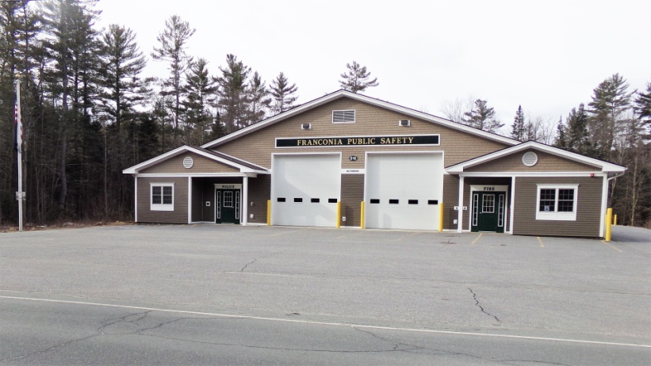

2016. Ladder 48. A used 1995 Simon-Duplex, 105 ft aerial ladder with a 1500 GPM pump.
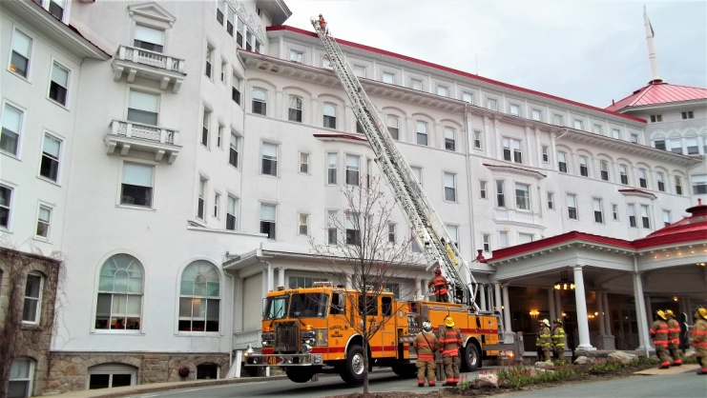

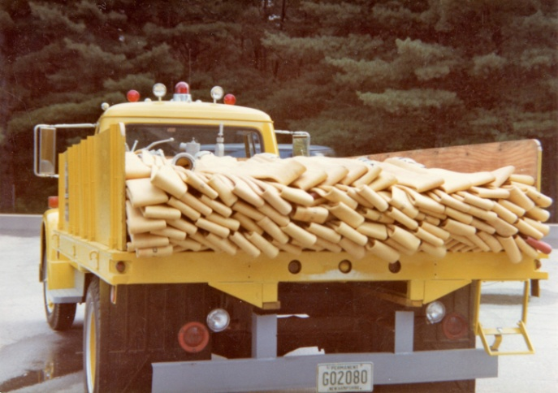 International hose truck

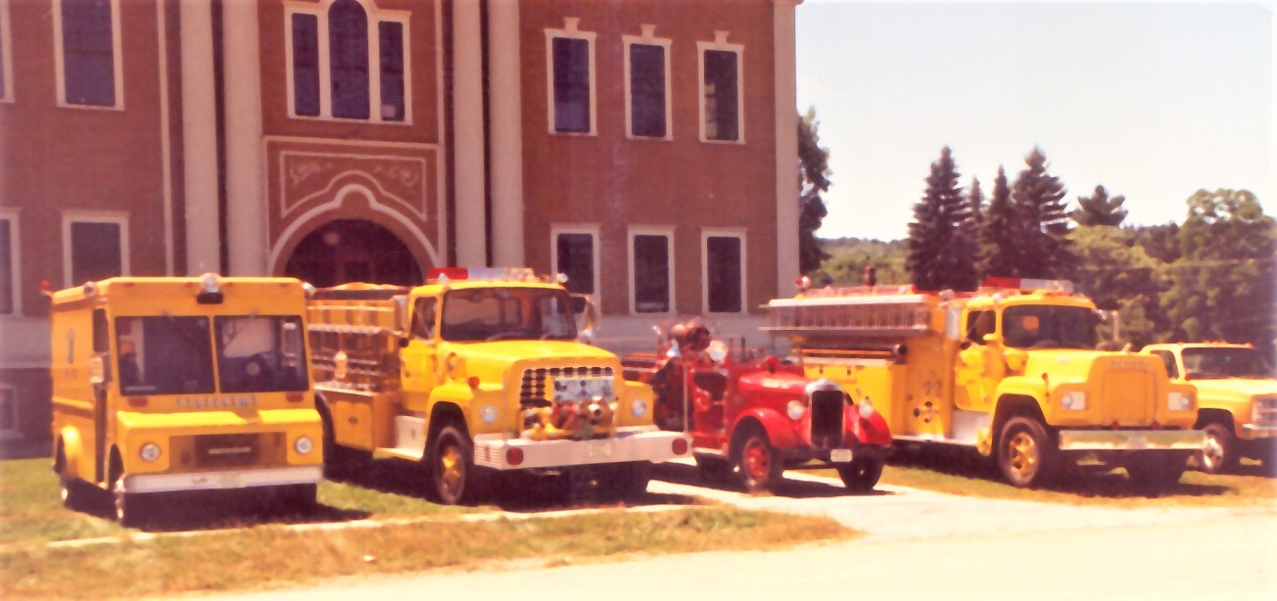 1982

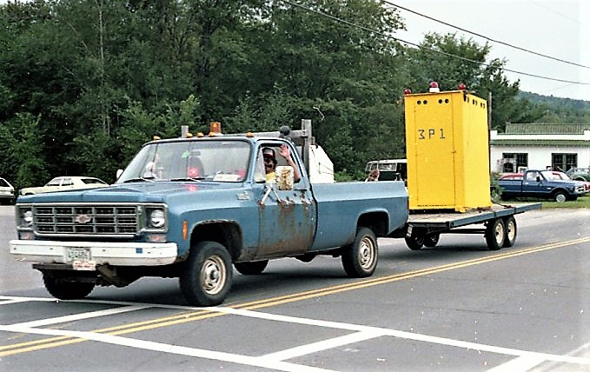 3 P 1 1978
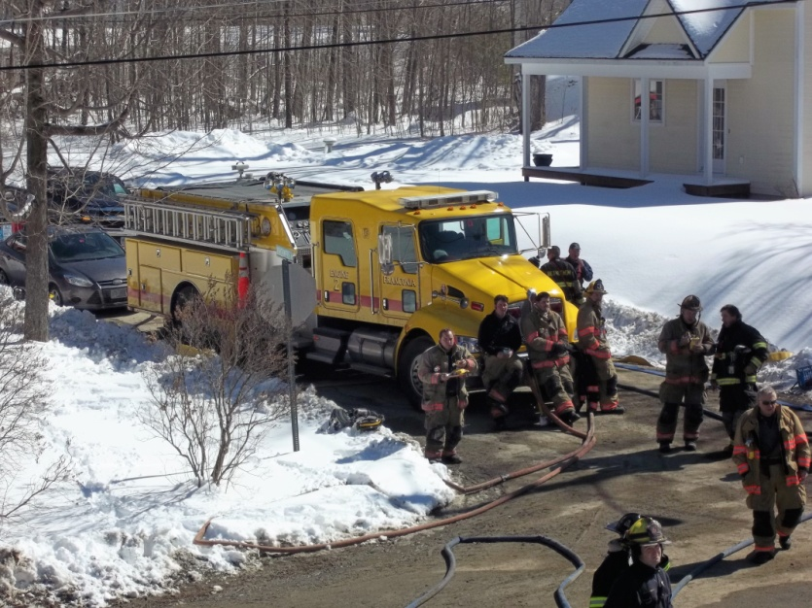 Franconia Engine 2, 2017

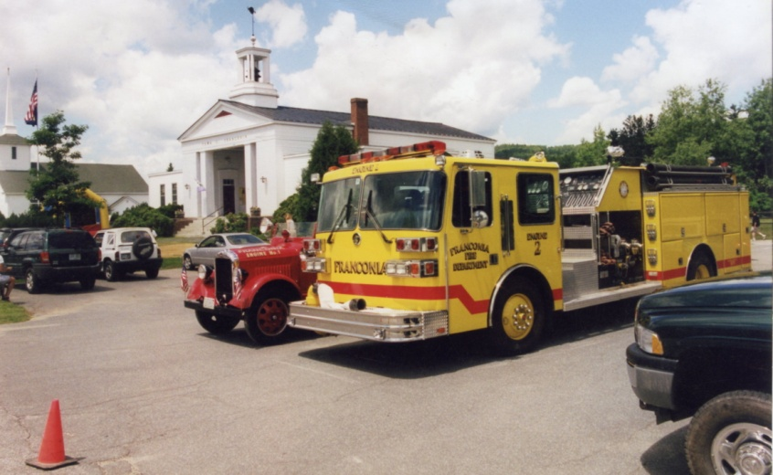 Franconia Engine 2, 2000

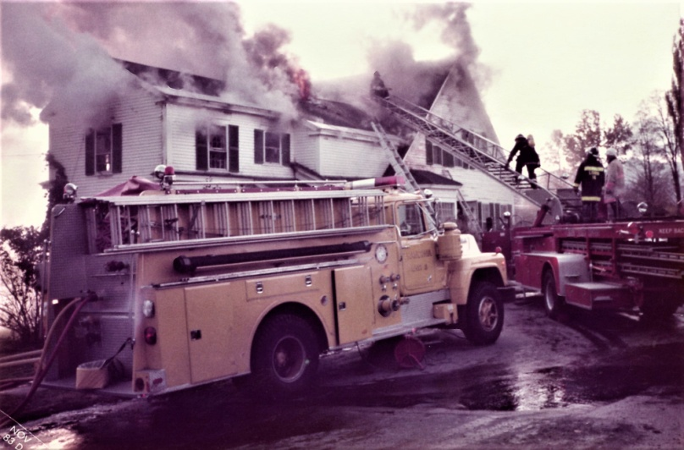 Franconia Engine 3, 1983 at the Homestead Annex, Sugar Hill

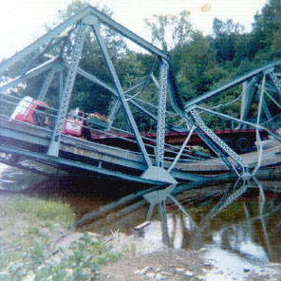 Rt.117 & Main St. Bridge collapse 1972

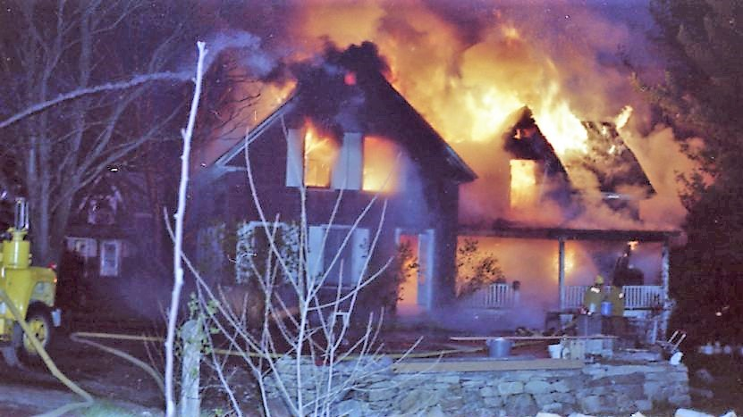 River St. 1978

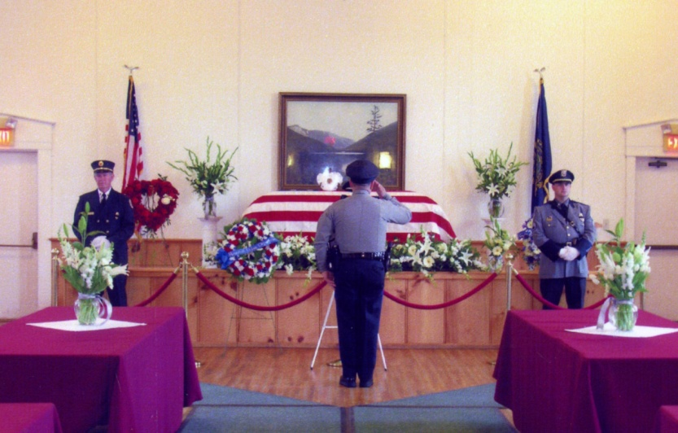
May 17, 2007, Bruce McKay Memorial Service. A Franconia Police Dept. Officer
FFD Participated
Franconia Fire Chiefs

Chief Bert Herbert 1934 to 1939

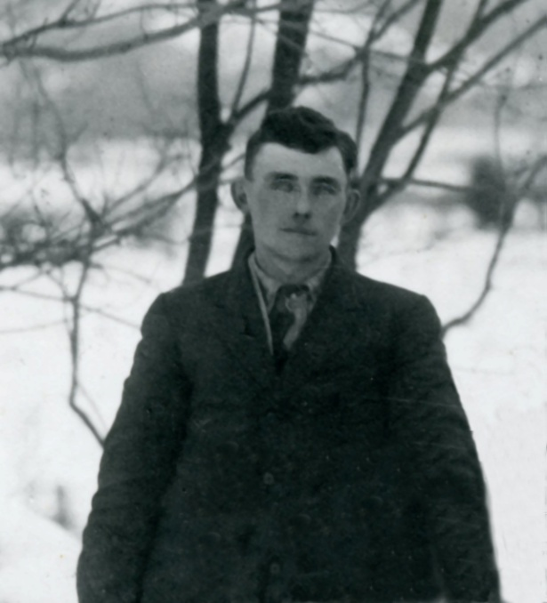

Chief Paul Rich 1940 to 1941 NoPicture

Chief Perry Ball 1941 to 1954 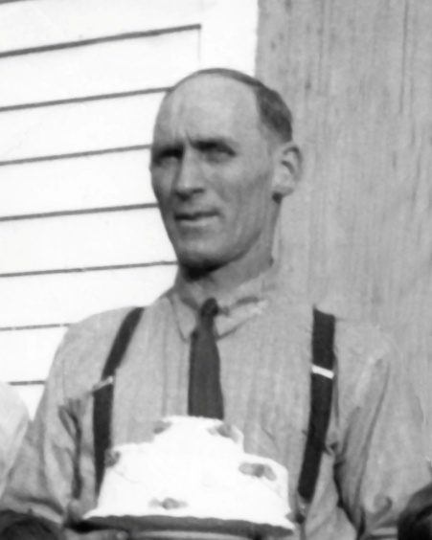
Perry is the father of Bob Ball and grandfather of Cray Ball members of FFD

Chief Edward Dexter 1955 to 1956 No picture

Chief Merton Shores 1956 to 1965 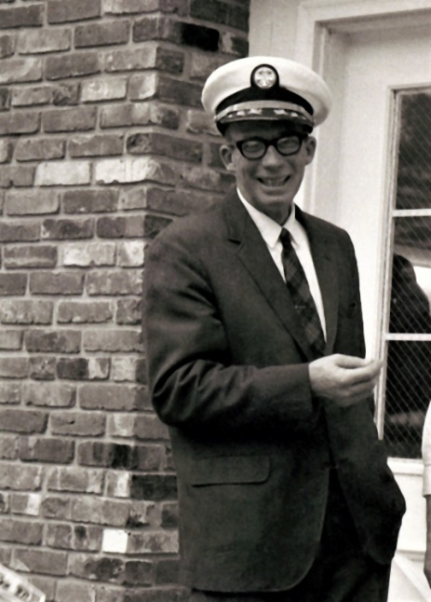

Chief Charles Herbert 1966 to 1968 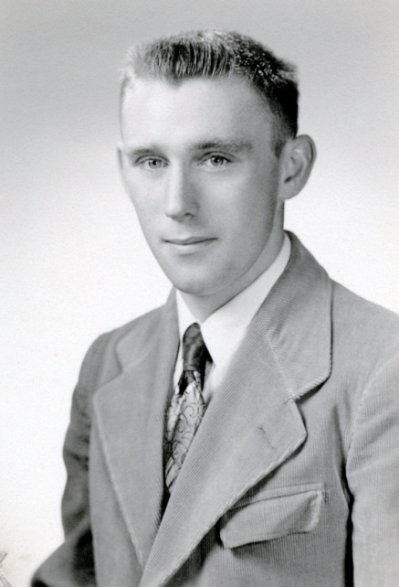
Sonny died suddenly in January 1968 while he was pumping water for the fire department. Chief Merton Shores returned and took over duties as chief until 1970.

Chief John Whitcomb 1970 to 1973 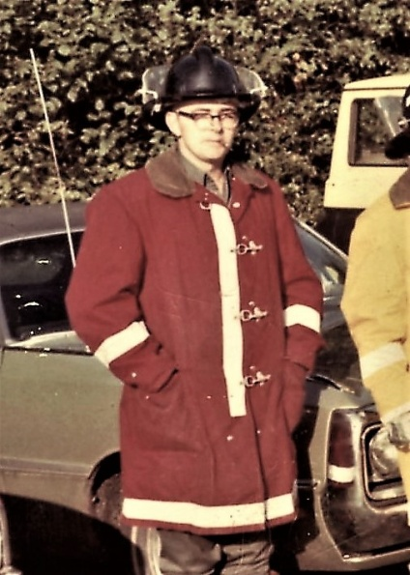 John left Franconia Fire to accept a full-time position as a firefighter in Hanover New Hampshire.

Chief Roger Odell 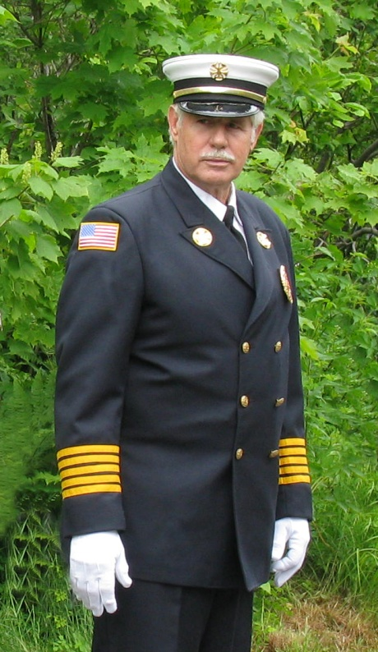 Roger served as the fire chief for three separate terms from 1974 to 1976, 1983 to 1984, and 2002 to 2005 for a total of 9 years as chief.

Chief George Whitcomb 1977 to 1982 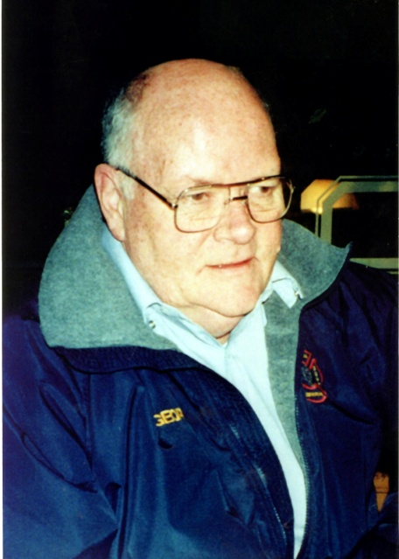 George was a member of the fire department for 51 years and Forest Fire Warden for many years also.

Chief Ron Hunt 1985 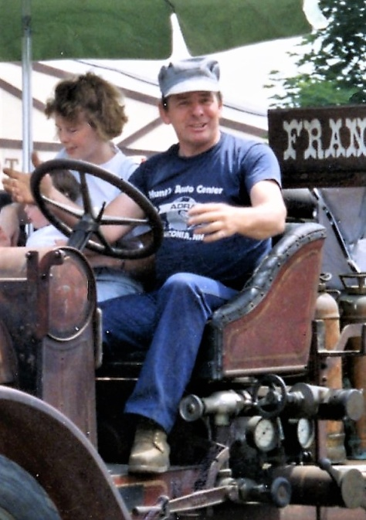 Ron served only one year as fire chief.

Chief William Mead 1986 to 1999 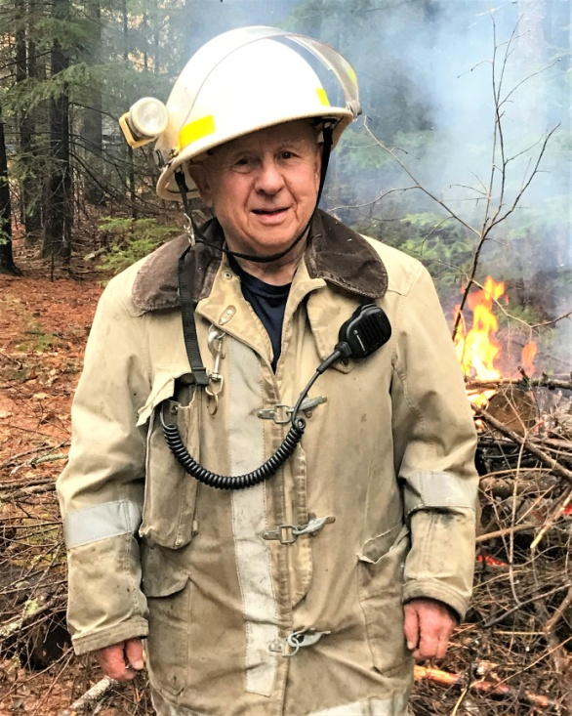
Bill and Perry Ball each served 14 years as fire chief, the longest term of any chief.

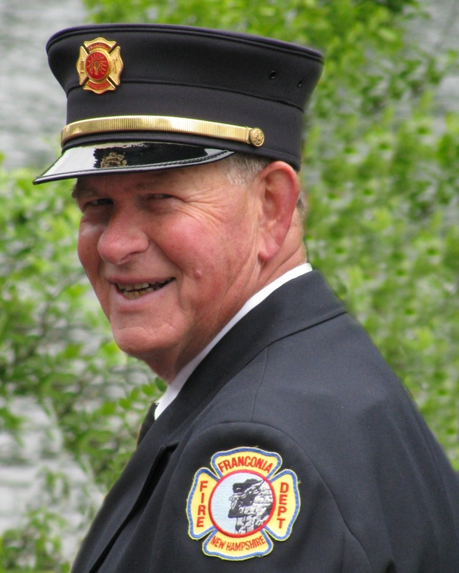

Chief Harvey Flanders 2000 to 2001 Harvey also did fire code inspections

Chief Richard McLachlin 2006 to 2010 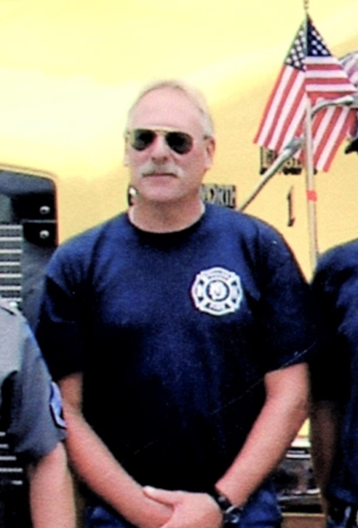 Mac is the son of Fireman Robert McLachlin 1957 to 1967

Chief Rick Gaudette 2011-- 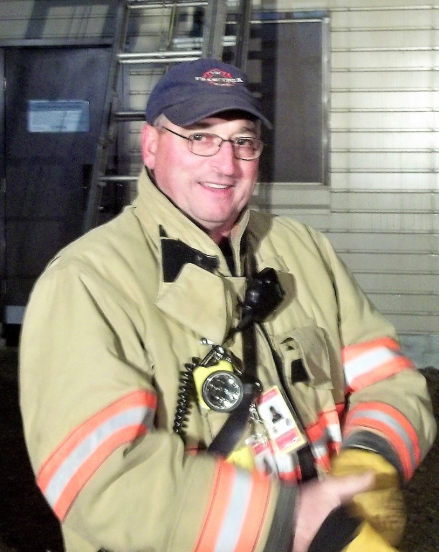 Rick is the current fire chief in 2020 and he has two sons currently serving as a firefighter for FFD, Peter and Tyler Gaudette

Franconia Fire Dept Roster 1933 to 2020*
Member | Base Year | Last Year Served | Total Years
Aldrich, James | 1962 | 1965 | 4
Allison, Catheron | 1963 | 1964 | 2
Andross, Richard | 1983 | 1984 | 2
Baillardgeon, Ron | 2015 | 2020 | 6
Ball Cray |  |  | 42 | a combined total of 42 yr
Ball, Cray ( 2 ) | 2000 | 2020 | 21
Ball, Cray (1) | 1965 | 1985 | 21
Ball, Perry Chief* 1941-1954 | 1934 | 1954 | 21 | Assumed to be a charter member
Ball, Robert* | 1957 | 1985 | 29 | Father of Cray Ball
Bernier, Leo | 1962 | 1974 | 13
Boudher, Jeffrey | 1970 | 1972 | 3
Bowles, Harold* | 1934 | missing data 1934-1957 |  | Assumed to be a charter member
Bowles, Roy* | 1938 | missing data 1934-1957
Briggs, William | 1973 | 1984 | 12
Brocklemen, Curtis | 1958 | 1987 | 30
Brodrick, Joe | 1958 | 1962 | 5
Brooks, Merrill | 1958 | 1986 | 29
Brown, Harry | 1971 | 1972 | 2
Brown, Lani | 2005 | 2008 | 4 | Sister of Shaw Brown
Brown, Shaw | 2015 | 2020 | 6 | Brother of Lani Brown
Canelas, Brian* | 2004 | 2008 | 5 | * missing data 91 to 04
Carbee, William* | 1934 | missing data 1934-1957 |  | Assumed to be a charter member
Carpenter, Harry | 1934 | 1964 | 30 | Assumed to be a charter member
Carroll, Jim* | 1990 | 1991 | 2 | * missing data 91 to 04
Cartheron, Allison | 1965 | 1970 | 6
Casey," Butch"Charles | 1979 | 1988 | 10
Cassidy, Arthur* | 1957 | 1965 | 9 | missing data 1934 to 1957
Champagne, Damus | 1959 | 1981 | 23
Champagne, Lise | 1976 | 1978 | 3 | Daughter of D. Champagne
Chase, Edward* | 1934 | missing data 1934-1957 |  | Assumed to be a charter member
Clark, Clement* | 1934 | missing data 1934-1957 |  | Assumed to be a charter member
Clark, Harold* | 1934 | missing data 1934-1957 |  | Assumed to be a charter member
Cowles, Kim | 2012 | 2019 | 8 | Wife of T. Cowles
Cowles, Tim | 1991 | 2004 | 14 | Husband of Kim Cowles
Crow, Nelson* | 2004 | 2010 | 7 | * missing data 91 to 04
Curtis, Harvey | 1963 | 1971 | 9
Dauphine, James | 1964 | 1965 | 2
Dempsey, William | 1976 | 1977 | 2
Dexter, Edgar Chief * | missing data 1934 to 1957 |  |  | chief 1955-1956
Dietlein, Darrel | 2008 | 2015 | 8
Doolan, Michael | 1965 | 1976 | 12 | Son of E. Doolan
Doolan,Ernest | 1960 | 1974 | 15
Doughty, Pat | 1999 | 2011 | 13
Eastman, Don | 1957 | 2010 | 54
Eastman, Ken | 2011 | 2014 | 4 | Son of Don Eastman
Finn, Robert | 1964 | 1975 | 12
Flanders, Harvey Chief | 1992 | 2018 | 27 | Chief 2000 to 2001
Ford, Thomas | 1962 | 1965 | 4 | Son of Ham Ford
Ford, Wendy | 1977 | 1984 | 8 | Wife of Tom Ford
Ford, Hamilton* | 1957 | 1962 | 6 | missing data 1934 to 1957
Gaudette, Peter | 2002 | 2020 | 19 | Son of R. Gaudette
Gaudette, Rick Chief | 1980 | 2020 | 41 | Chief 2011 ---
Gaudette, Tyler | 2007 | 2020 | 14 | Son of R. Gaudette
Gawel, Randy* | 1988 | 1991 | 4 | * missing data 91 to 04
Gilbert, Judy | 1980 | 1984 | 5 | Daughter of R. Gilbert
Gilbert, Mike* | 1983 | 1991 | 9 | Son of R. Gilbert
Gilbert, Robert | 1968 | 1983 | 16
Gerard, Jerry | 1980 | 1988 | 9
Glover, Doug* | 1986 | 1991 | 6 | Son of Rorer Glover
Glover, Roderick | 1958 | 1966 | 9
Glover,Roger* | 1957 | 1966 | 10 | missing data 1934 to 1957
Grima, Rick | 2011 | 2013 | 3
Grote, William | 2018 | 2019 | 2
Hall, Edward* | 1938 | missing dada 19341957
Hall, Jeremy | 2015 | 2016 | 2
Harrison, Jack* | 1983 | 1991 | 9 | * missing data 91 to 04
Hartshorn, Jerry | 1964 | 1966 | 3
Heath, William* | 1938 | missing data 1934-1957
Hening, Scott | 1980 | 1984 | 5
Herbert, Bert* | 1934 | missing data 1934-1957 |  | Assumed to be a charter member
Herbert, Charles Chief | 1963 | 1968 | 6 | Chief 1966-1968
Herbert, Henry | 1958 | 1962 | 5
Hilgenberg, Carl | 1966 | 1986 | 21
Holland, Ray | 1969 | 1970 | 2
Hoyle, Ted | 2009 | 2017 | 9
Hubbard, F. | 1969 | 1970 | 2
Hultgren ,William | 1988 | 1990 | 3 | Son of T. Hultgren
Hultgren,Theodore | 1961 | 1969 | 9
Hunt, Winton | 1934 | 1963 | 29 | Assumed to be a charter member
Hunt,Ronald Chief | 1965 | 1989 | 25 | 1962 on payroll Chief 1985 to 1986
Husson, Andrew | 2015 | 2020 | 6
Hutchins,Lee | 1962 | 1963 | 2
Ireland, Leigh* | 2004 | 2005 | 2 | * missing data 91 to 04
Jasmin,Clatyton* | 1957 | 1965 | 9 | missing data 1934 to 1957
Jasmine,Perley* | 1957 | 1957 | 1 | missing data 1934 to 1957
Jervis, Tom | 1971 | 1976 | 6
Johnson, W Jr. | 1958 | 1961 | 4
Kiedaisch, Glen | 1971 | 1978 | 8
Kiernan, Marc | 1971 | 1973 | 3
Knowlton, Scott | 2007 | 2007 | 1
LaDuke, Steve | 1982 | 1984 | 3
Larson, Eric (1) | 1982 | 1983 | 2
Larson, Eric ( 2 ) | 1988 | 1990 | 3
Lawrence, Robert* | 1957 | 1966 | 10 | missing data 1934 to 1957
Leary, Tim | 1974 | 1976 | 3
Lewis, Elwood* | 1934 | missing data 1934-1957 |  | Assumed to be a charter member
Lock, I | 1984 | 1985 | 2
Lougee,Edward | 1962 | 1963 | 2
Lovett, Bill | 1976 | 1987 | 12
Luce, Kirk | 2003 | 2016 | 14
McCarhy, William | 2015 | 2020 | 6
McCutcheon, Robert | 1980 | 1983 | 4
McIntosh, Jim | 1989 | 2007 | 19
McLachlin,Richard Chief | 1970 | 2010 | 41 | chief from 2006 to 2010
McLachlin,Robert* | 1957 | 1969 | 13 | Father of Richard McLachlin
McPhaul, Chris* | 1990 | 1991 | 2 | * missing data 91 to 04
Mead, William Chief | 1976 | 1999 | 24 | Chief 1986 to 1999
Meade, Charles | 1969 | 1972 | 4
Mellekas, William | 1988 | 1988 | 1
Miller, George* | 1934 | missing data 1934-1957 |  | Assumed to be a charter member
Mitten, G | 1960 | 1960 | 1
Moody, Clarence | 1963 | 1973 | 11
Nelson, Carl Jr.* | 1938 | missing data 1934-1957
Nelson, Ernest* | 1934 | missing data 1934-1957 |  | Assumed to be a charter member
Nelson, Glenn* | 1957 | 1957 | 1 | missing data 1934 to 1957
O’Hara, Ryan | 2011 | 2013 | 3
Odell Roger Chief |  |  | 47 | a combined total of 47 yr.
Odell, Roger (1) | 1970 | 1984 | 15 | Chief 1974 to 1977
Odell, Roger ( 2 ) | 1989 | 2020 | 32 | Chief 1983 to 1984
Osgood, John | 1976 | 1982 | 7
Palmer, Tom | 2003 | 2015 | 13 | Brother of W. Palmer
Palmer, Walter | 2014 | 2020 | 7 | Brother of T. Palmer
Parceii, Michael | 2009 | 2012 | 4
Payette, Karen | 1979 | 1985 | 7 | Daughter of P. Payette
Payette, Phillip | 1960 | 2015 | 56
Peabody, Brett | 1980 | 1984 | 5 | Son of Jere Peabody
Peabody, Jere | 1969 | 1973 | 5 | Brother of Joe & John Peabody
Peabody, Joel | 1962 | 1984 | 23 | Brother of John & Jere Peabody
Peabody, John | 1969 | 1973 | 5 | Brother of Joe & Jere Peabody
Peckett, John | 1989 | 2014 | 26
Peoples, Alex | 2014 | 2020 | 7
Pineo, Kirman | 1962 | 1976 | 15
Place, John | 1985 | 1987 | 3
Prentiee, Philip* | 1957 | 1958 | 2 | missing data 1934 to 1957
Pryor, Ken | 1974 | 1975 | 2
Raynor, Craig | 1963 | 1969 | 7
Rich, Paul Chief* | 1938 | missing data 1934-1957 |  | Chief 1940-1941
Sanborn, Louis | 1978 | 1982 | 5
Sargent, J | 1984 | 1984 | 1
Sherburn, Brandon | 2001 | 2010 | 10 | Son of S. Sherburn
Sherburn, Jodi | 1998 | 2008 | 11 | son of S. Sherburn
Sherburn, Robert | 1969 | 1972 | 4 | Brother of S.Sherburn
Sherburn, Stanley | 1971 | 2020 | 50
Shores,Merton Chief* | 1957 | 1973 | 17 | Chief 1956 to 1965 1968 to 1969
Smiles, Richard* | 1980 | 1991 | 12 | * missing data 91 to 04
Smith," Butch" Gerald | 1977 | 1984 | 8
Sorenson, Paul* | 1984 | 1991 | 8 | * missing data 91 to 04
Spillane,L | 1959 | 1960 | 2
Stowell, Chandler | 1965 | 1967 | 3
Stroup, George | 1980 | 1989 | 10
Stroup, Kim | 1980 | 1982 | 3 | Wife of G. Stroup
Sullivan, Richard | 1938 | 1964 | 26 | was on a 1938 roster 26yr.
Talbot, Rusty | 2014 | 2016 | 3
Taylor, Donald* | 1938 | missing data 1934-1957
Tomasseti, Lin | 1986 | 1989 | 4
Tucker, George* | 1983 | 1991 | 9 | * missing data 91 to 04
Tuite, Brody | 2011 | 2013 | 3
Tuttle, Hal* | 1984 | 1991 | 8 | * missing data 91 to 04
Venezia, Mark | 2008 | 2013 | 6
Vintinner,Charles | 1961 | 1962 | 2
Walch, Paul* | 1934 | missing data 1934-1957 |  | Assumed to be a charter member
Walsh, William | 1985 | 2004 | 20
Waters, James* | 1957 | 1967 | 11 | missing data 1934 to 1957
Welch, John | 1934 | 1960 | 27 | Assumed to be a charter member
Wessels, Wilfred* | 1957 | 1987 | 31 | missing data 1934 to 1957
Wessels,William | 1965 | 1967 | 3
Westhaver, J | 1958 | 1961 | 4
Whitcomb, George Chief | 1964 | 2014 | 51 | Chief 1977 to 1982
Whitcomb, Stephen | 1982 | 1986 | 5 | son of G Whitcomb
Whitcomb, John Chief | 1962 | 1975 | 14 | Chief 1970 to 1974
Wright, Dean | 1986 | 2008 | 23
Zuk,William | 1962 | 1977 | 16

Longest Serving FFD Members

Phillip Payette 56 year FFD member
Don Eastman 54 year FFD member
George Whitcomb 51 year FFD member

Members with 20 years and more
Member | Base Year | Last Year Served | Total Years
Payette, Phillip | 1960 | 2015 | 56
Eastman, Don | 1957 | 2010 | 54
Whitcomb, George chief | 1964 | 2014 | 51 | Chief 1977 to 1982
Sherburn, Stanley | 1971 | 2020 | 50
Odell Roger Chief |  |  | 47 | a combined total of 47 yr.
Ball Cray |  |  | 42 | a combined total of 42 yr
Gaudette, Rick Chief | 1980 | 2020 | 41 | Chief 2011 ---
McLachlin , Richard Chief | 1970 | 2010 | 41 | chief from 2006 to 2010
Wessels, Wilfred* | 1957 | 1987 | 31 | missing data 1934 to 1957
Brocklemen, Curtis | 1958 | 1987 | 30
Carpenter, Harry | 1934 | 1964 | 30 | Assumed to be charter member
Ball, Robert* | 1957 | 1985 | 29 | Father of Cray Ball
Brooks, Merrill | 1958 | 1986 | 29
Hunt, Winton | 1934 | 1963 | 29 | Assumed to be charter member
Flanders, Harvey Chief | 1992 | 2018 | 27 | Chief 2000 to 2001
Welch, John | 1934 | 1960 | 27 | Assumed to be charter member
Peckett, John | 1989 | 2014 | 26
Sullivan, Richard | 1938 | 1964 | 26 | was on a 1938 roster 26yr.
Hunt,Ronald Chief | 1965 | 1989 | 25 | Chief 1985 to 1986
Mead, William Chief | 1976 | 1999 | 24 | Chief 1986 to 1999
Champagne, Damus | 1959 | 1981 | 23
Peabody, Joel | 1962 | 1984 | 23 | Brother of John & Jere Peabody
Wright, Dean | 1986 | 2008 | 23
Ball, Cray ( 2 ) | 2000 | 2020 | 21
Ball, Cray (1) | 1965 | 1985 | 21
Ball, Perry Chief *1941-1954 | 1934 | 1954 | 21 | Assumed to be charrter member
Hilgenberg, Carl | 1966 | 1986 | 21
Walsh, William | 1985 | 2004 | 20

*This roster list was compiled from payroll records, meeting attendance records, and activity logs. The Fire Department has meeting attendance and payroll records back to 1957 and activity log’s started in the 1980s. When a member first appeared on these records for the year they would be considered an active member. Likewise, when a member stopped appearing on the records they were considered retired. The records are missing from 1991 to 2004 and there will be members who joined and retired in that time frame and their will not be known. Most members that joined between 1991 and 2004 and were still active after 2004 were contacted for the year they joined.
Members that were active before 1991 and retired before 2004 will not have an accurate count of years served. Before 1957 if there were any records kept, they have not been found. In the 1936 and 38 Town Reports, there was a list of firefighters and they have been included in this roster. Some of these firefighters were still active after 1957, and again there will be members who joined and retired from the department in this pre-1957 period that will be lost.

Aldrich Store Fire

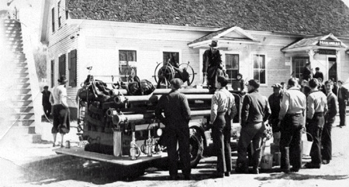
This picture was probably taken before 1940 because the building behind the engine, you can see the entrance to the post office that was moved into the New Town Hall that was built in about 1939. This building was torn down in 1960 to make way for Aldrich's new store that is still now a grocery store on Main Street. The stairs on the left of the picture went to apartments over the store. This building was also torn down. Take note of the schoolboys holding fire buckets.
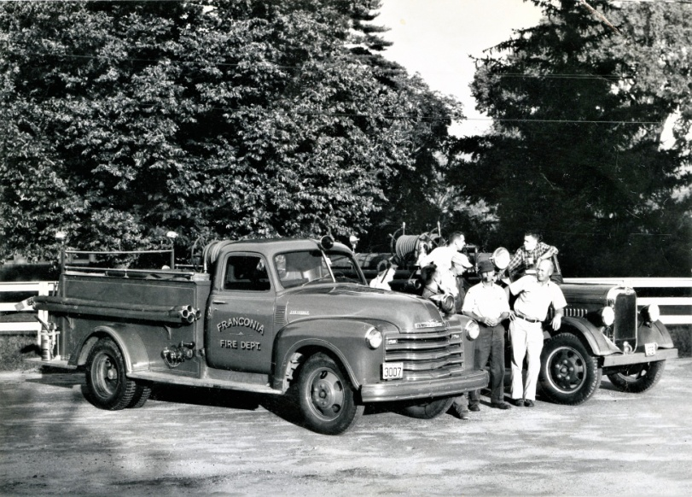
Chief Merton Shores leaning against the truck and to his right, smoking pipe Richard Sullivan directly behind Sullivan with ball cap is Harry Carpenter and directly behind Carpenter is Sonny Herbert, The other 3 men unknown. About 1958
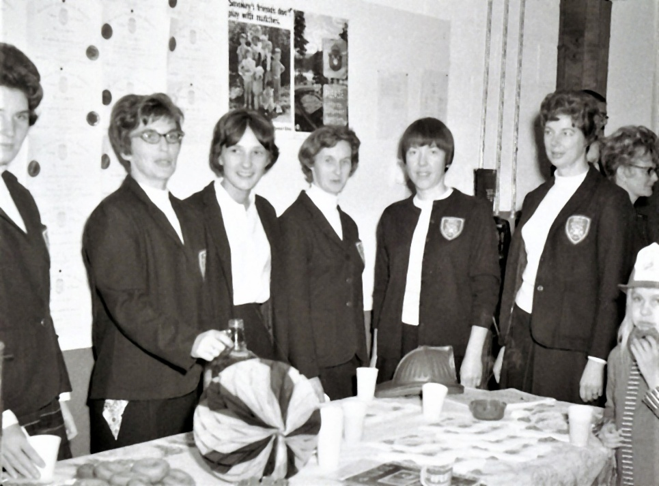
FFD Auxiliary L-R Linda Whitcomb, Lois Champagne, Mary Ellen Gilbert, Kay Whitcomb, Lucy Finn, Marge Wessels 1969

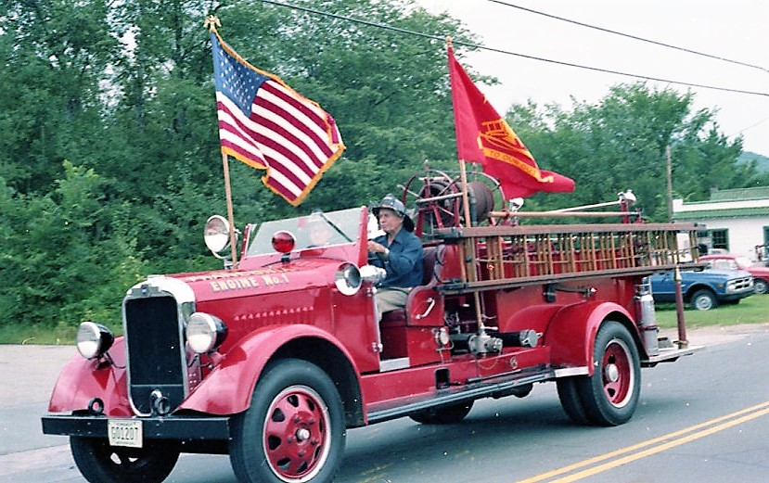 Curtis Brockelman driving and Merrill Brooks is passenger 1981

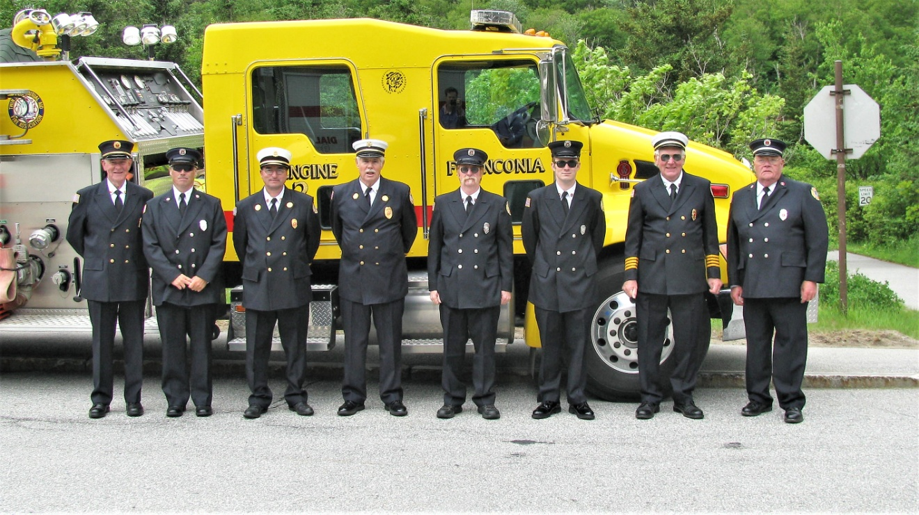
Harvey Flanders, Cray Ball, Rick Gaudette, Roger Odell, Kirt Luce, Brody Tuite, Stanley Sherburn, George Whitcomb June 12, 2011
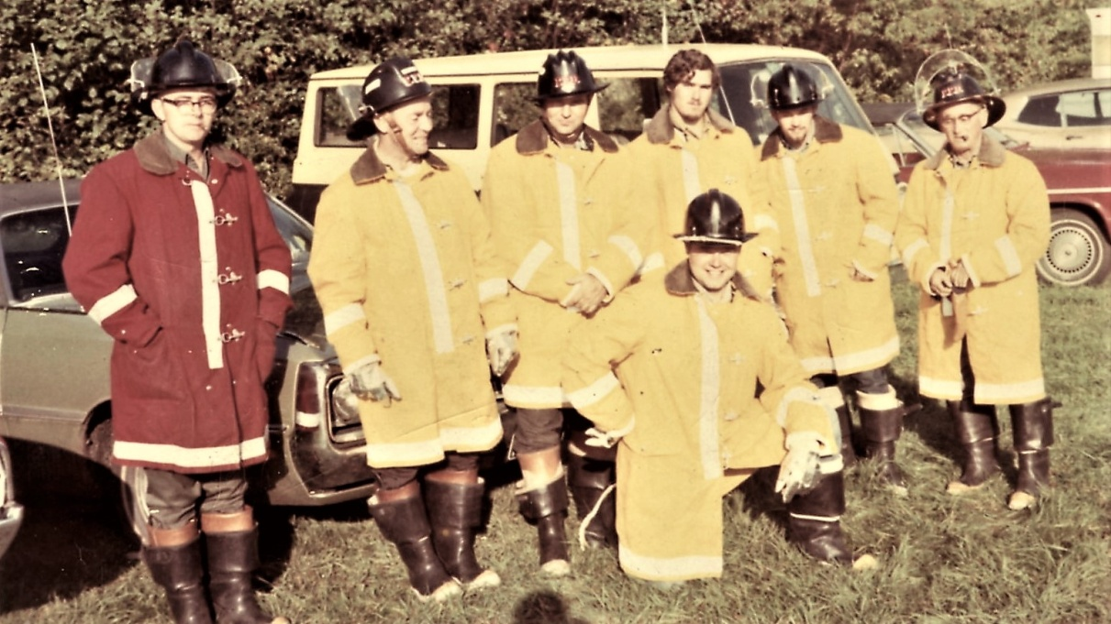
L-R John Whitcomb, Bob Finn, Ernest Doolan, Cray Ball, unknown, Merrill Brooks, kneeling Jeffrey Boudher about 1972

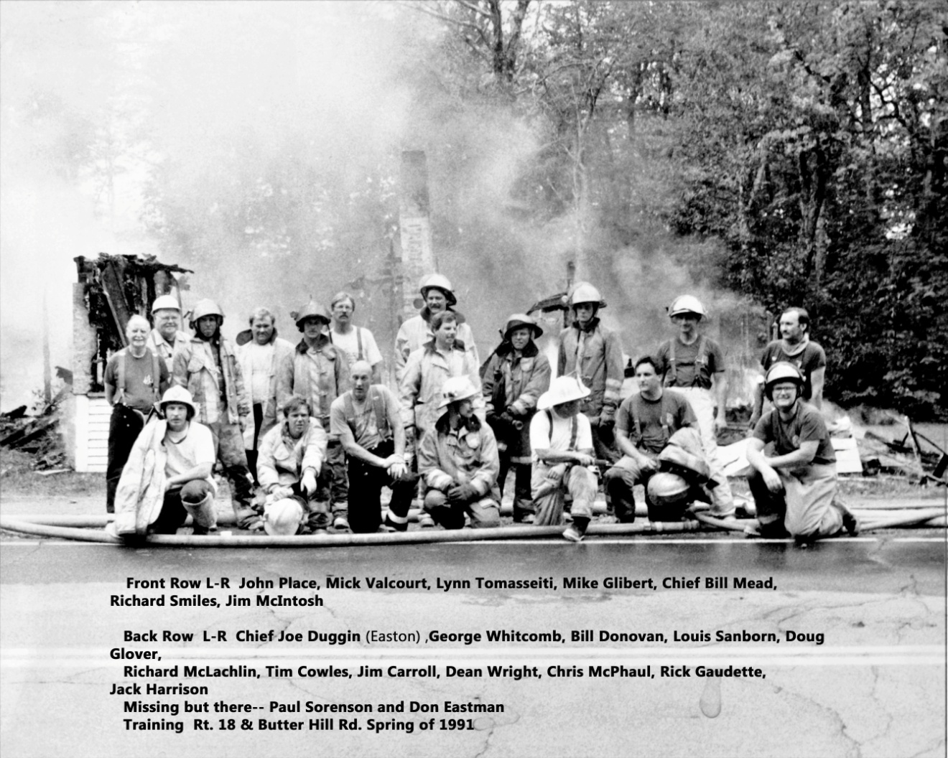

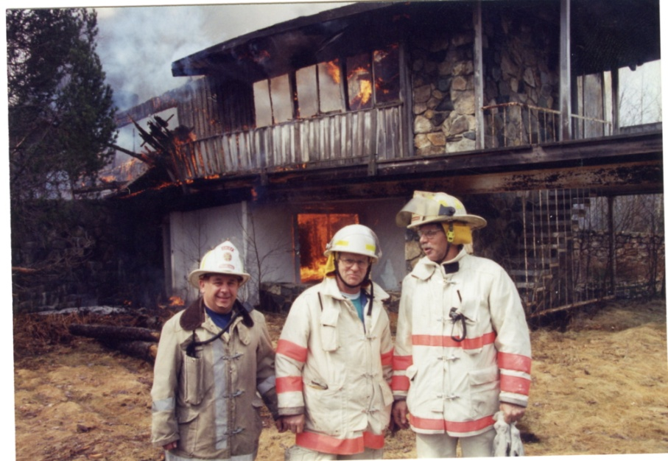
Bill Mead, Butch Casey, Richard McLachlin, about 1995

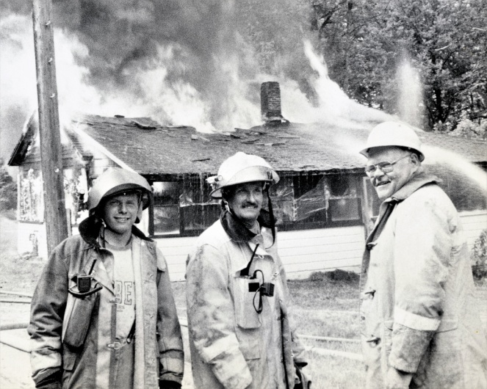
L to R Dean Wright, Jack Harrison, George Whitcomb Spring 1991

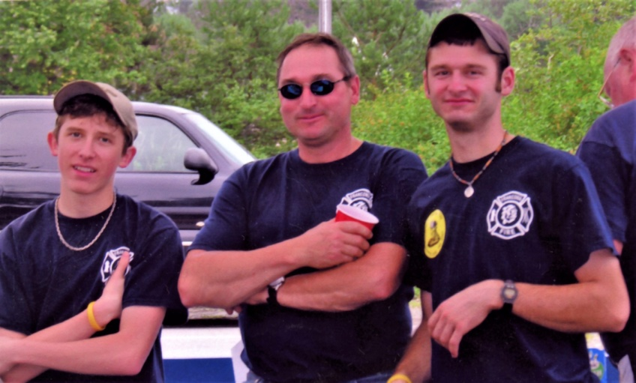
Tyler, Rick & Peter Gaudette July 4, 2007

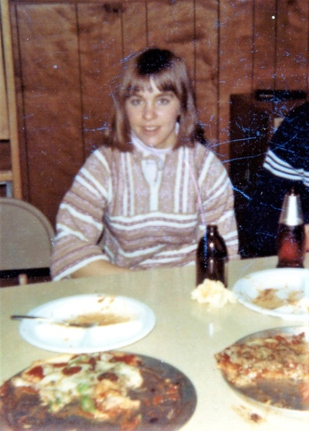
Lisa Champagne FFD first woman member 1976

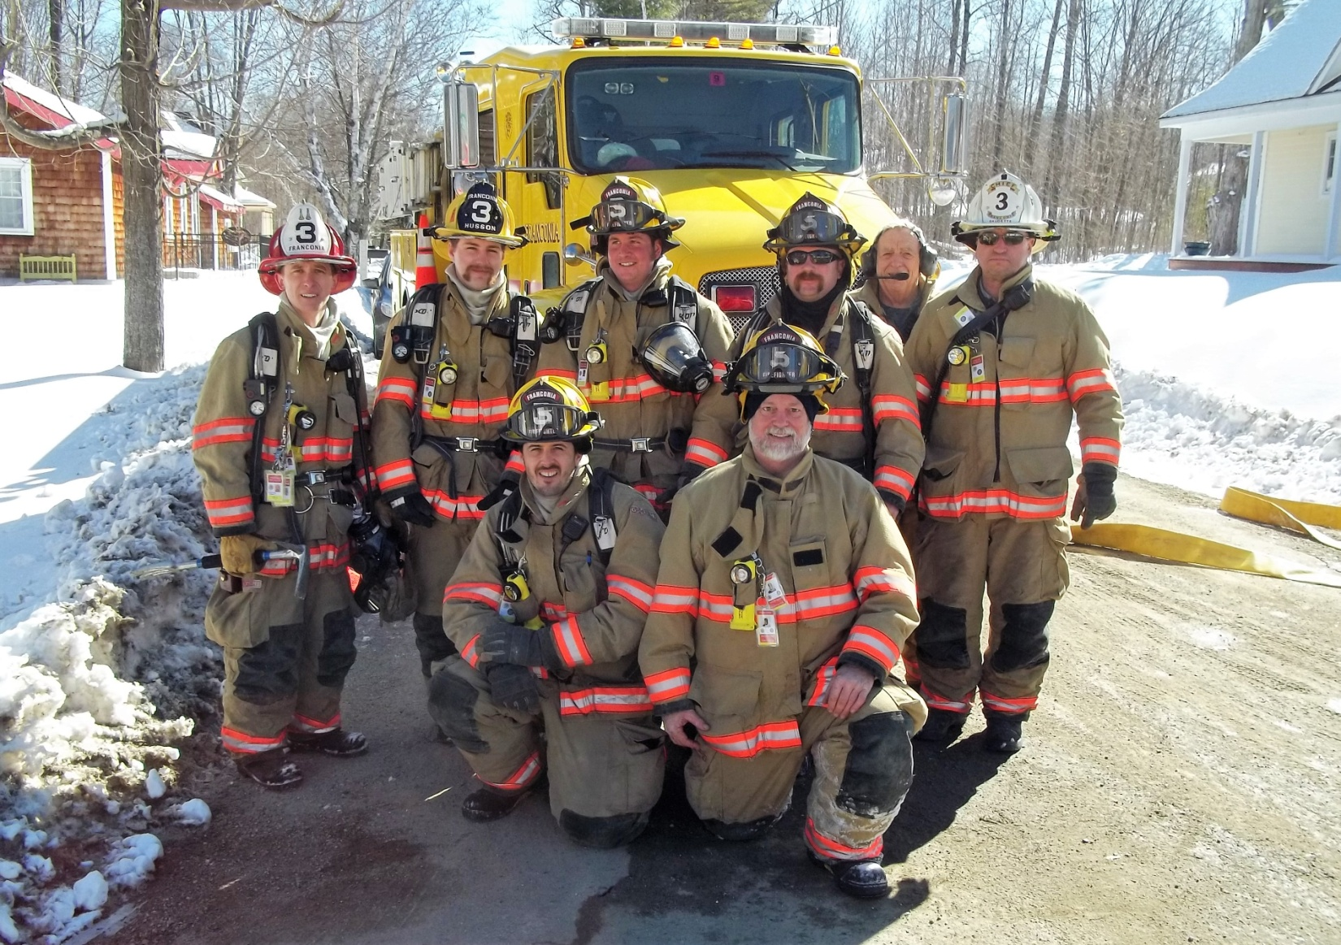
Front. Shaw Brown, Walter Palmer Standing. Tyler Gaudette, Andrew Husson, Alex Peoples, Bill McCarthy, Ron Baillargeon, Rick Gaudette, March 2017

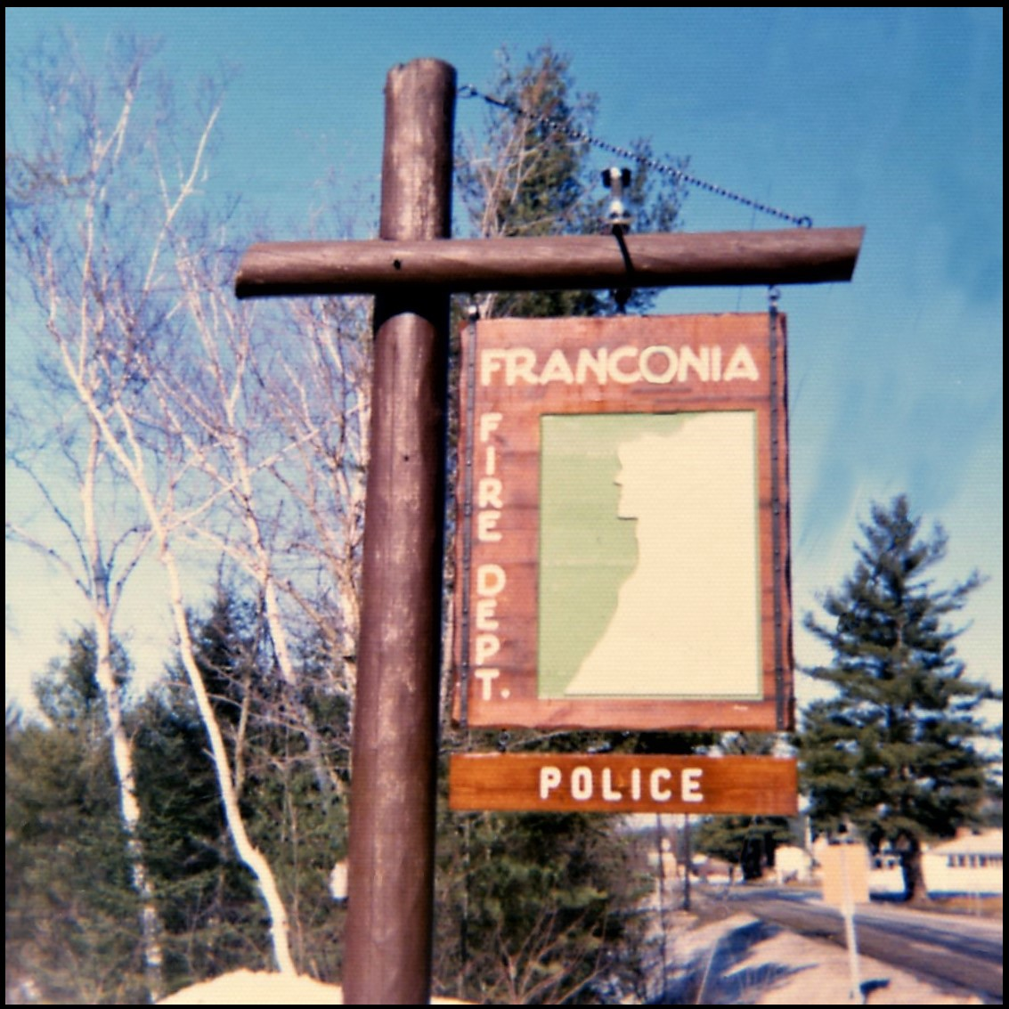
Sign Made by Robert Finn. 1972

